2022 Coordinated Public Transit-Human Services Transportation Plan for Ada and Canyon Counties
Report Number 11-2022 August 2022

Table of Contents

Table of Contents 2
Introduction 3
Part 1. Existing Conditions 8
Summary 8
Chapter 1 | Funding Programs 10
Section 5310 Program 10
Other Funding Programs 12
FTA Funding Amounts 13
State of Idaho Funding Programs 15
Chapter 2 | Existing Transportation Services 16
Regional Transportation Authority 17
Specialized Transportation 20
Public-Private Partnerships 25
Commuter Services 26
Independent Operators 28
School-Contracted Operators 28
Long-Distance Transit Operators 28
Taxi and Rideshare Companies 29
Chapter 3 | Demographic Changes 30
Part 2. Identifying and Addressing Unmet Transportation Needs 43
Chapter 4 | Public Survey 44
Chapter 5 | Unmet Transportation Needs, Priorities, and Strategies 46
Public Survey 46
Detailed Survey Results 47
Prioritization Process 48
Chapter 6 | Implementation 53
Biennial Report 53
Performance Measures for the Coordinated Plan 53
Chapter 7 | Conclusion 54
Appendices 55
Appendix A | Valley Regional Transit Specialized Transportation Analysis: Background and Overview 55
Appendix B | Survey 1: Community Advocate Survey 75
Appendix C | Survey 2: Stakeholder Survey 76
Appendix D | Outreach Process and Public Comment Received 79

Introduction
Public agencies in Ada and Canyon Counties, Idaho — the “Treasure Valley” — continually strive to improve the coordination and provision of public transportation services to underserved populations. The 2022 Coordinated Public Transit-Human Services Transportation Plan for Ada and Canyon Counties, or “Coordinated Plan,” is the newest iteration of a plan that seeks to better understand the transportation needs of underserved populations and identify strategies to address them.
This plan was developed by the Community Planning Association of Southwest Idaho (COMPASS), the metropolitan planning organization (MPO) for Ada and Canyon Counties, and Valley Regional Transit (VRT), the regional public transportation authority for Ada and Canyon Counties.

Plan Organization
This plan is organized in two parts: Part 1: Existing Conditions and Part 2: Identifying and Addressing Unmet Transportation Needs.
Part 1 describes the current state of public transportation and demographic trends in the Treasure Valley. This section includes the following chapters: Chapter 1: Funding Programs, Chapter 2: Existing Transportation Services, and Chapter 3: Demographic Changes 2010 to 2019.
Part 2 identifies unmet transportation needs of target populations and how the Coordinated Plan seeks to address these needs. This section includes the following chapters: Chapter 4: Public Survey, Unmet Transportation Needs, Priorities, and Chapter 5: Strategies, and Chapter 6: Implementation.

Geographic Scope
The scope of this plan is limited to Ada and Canyon Counties, Idaho, which is the area served by both VRT and COMPASS.

Stakeholders
The Coordinated Plan identifies the unmet transportation needs of target populations, provides strategies to meet these needs, and prioritizes transportation services for funding and implementation. Target populations included in this plan are:
- Persons with Disabilities
- Persons with Low-Incomes
- Older Adults (65 years old and older)
- Persons with Limited English Proficiency
This plan seeks address these target populations by better coordinating services and planning efforts with community advocates such as non-profits and regional advisory groups, and transit service providers.
Federal guidance only requires persons with disabilities, older adults, and persons with low income to be included in the Coordinated Plan; however, due to the unique vulnerabilities of persons with limited English proficiency, community advocates and service providers in Ada and Canyon counties chose to include them as a target population in the Coordinated Plan.
This plan was produced in partnership with the Regional Advisory Council (RAC), a standing committee of the VRT Board of Directors. RAC members include non-profit transportation and human services providers who represent target populations for this plan. RAC members provided key feedback on the development of this plan and distributed information about the Coordinated Plan to their stakeholders.

Regulatory Guidance
The Coordinated Plan is required for project proposals to be eligible to receive funding from the Federal Transit Administration’s (FTA’s) Section 5310 program - Enhanced Mobility of Seniors and Individuals with Disabilities (49 U.S.C. 5310) (click to link). On July 7, 2014, the FTA issued its most recent guidance on the administration of the Section 5310 program - Circular (C) 9070.1G, Enhanced Mobility of Seniors and Individuals with Disabilities Program Guidance and Application Instructions (click to link). This circular continues to guide Coordinated Plan development under the 2021 Infrastructure Investment and Jobs Act.

Public Participation
COMPASS developed a survey in fall 2021 to identify unmet transportation needs. Members of the RAC and six other regional advisory groups participated in and distributed the survey through their websites, mailing lists, and social media channels. The survey process and results are discussed in detail in Chapter 4.

A 31-day public comment period on the draft plan was held from April 15 to May 15, 2022, with one virtual and two in-person open houses. Targeted outreach to increase awareness of the plan was also conducted through online and off-line advertising. Public involvement materials were available in Spanish and English and accessible via screen reader. COMPASS received 14 comments. Following completion of the public comment period, more detail on the public comment period, including a copy of the comment form, all comments received, and a discussion of how comments were incorporated into the plan will be provided in Appendix D.

Previous Plans
The 2022 Coordinated Plan builds on more than a decade of human service transportation planning in the region.
- 2007: Transportation Service Coordinated Plan
  - VRT completed this study with the assistance of a consultant.
- 2009: Local Mobility Management Network (LMMN) 3C Mobility Plan
  - The Idaho Transportation Department (ITD) completed this plan as part of its Idaho’s Mobility and Access Pathways (IMAP) program. IMAP divided the state into 17 Local Mobility Management Networks (LMMNs) to coordinate and enhance transportation and mobility options. The 2009, 2011, 2013, and 2014 updates of the Coordinated Plan were merged with the LMMN Plan updates. The plan covers a six-county area of Ada, Boise, Canyon, Elmore, Gem, and Owyhee Counties.
- 2011: Local Mobility Management Network (LMMN) 3C Mobility Plan (click to link)
  - The Community Transportation Association of Idaho (CTAI) and ITD completed this plan. The plan covers a six-county area of Ada, Boise, Canyon, Elmore, Gem, and Owyhee Counties.
- 2013: Local Mobility Management Network (LMMN) 3C Mobility Plan (click to link)
  - CTAI and ITD completed this plan. The plan covers a six-county area of Ada, Boise, Canyon, Elmore, Gem, and Owyhee Counties.
- 2014: Local Mobility Management Network (LMMN) 3C Mobility Plan (click to link)
  - COMPASS completed this plan. For this plan, the planning boundaries for LMMNs changed to match the MPO planning boundaries. The plan covers Ada and Canyon Counties.
- 2022: Coordinated Public-Transit Human Services Transportation Plan
  - COMPASS completed this plan. The plan covers Ada and Canyon Counties.

Other Relevant Planning Documents
- 2011: Mobility Concept: Human Services Transportation Organizations, COMPASS (click to link)
- 2017: Idaho Public Transportation Office’s State Management Plan, ITD (click to link)
- 2018: Idaho Public Transportation Plan, ITD (click to link)
- 2018: Communities in Motion 2040 2.0, COMPASS (click to link)
- 2018: ValleyConnect Plan 2.0, VRT (click to link)
- 2020: High-Capacity Transit Study Update, COMPASS (click to link)
- 2020: Community Assessment, United Way (click to link)
- 2021: Regional Park and Ride Study, COMPASS (click to link)
- 2021: Regional Analysis of Impediments to Fair Housing Choice, Cites of Boise, Meridian, Caldwell, and Nampa (click to link)
- 2021 to 2023: Idaho State Plan for Independent Living, Idaho State Independent Living Council (SILC) (click to link)
- 2021 to 2025: Idaho State Independent Living Council Strategic Plan, SILC (click to link)

Review of Activities
In the eight years since the previous Coordinated Plan, VRT has worked to optimize financial, human, technical, and equipment resources and expand access to transportation for vulnerable populations. Over time, these efforts have evolved into services for older adults, persons with disabilities, veterans, refugees, and populations with low incomes. Highlights include:
Highlight #1: Better Coordinated Services for Older Adults. In 2011, the senior centers were losing a percentage of Area Agency on Aging Title 3-B funding due to recession-driven state budget cuts. This led to cuts in funding to insure and maintain vehicles and operate services. VRT became the designated recipient for Large Urban Section 5310 Program funding and gradually centralized efforts to coordinate programs. Initially, two of the rural senior center providers were collaborating. The senior centers shared the nutrition program and offered meals on alternating days for all seniors in their combined areas, applying for coordinated Section 5310 funding for transportation. Gradually, other programs were included, as the senior centers worked together and built trust. VRT also worked with FTA Region 10 to use Small Urban Federal public transit dollars for trips from rural area into larger urban areas, if one leg of the trip was within the urban area.
Highlight #2: Increased Efficiency of Specialized Services. In 2018, VRT was able to further build on its coordination efforts by becoming the recipient of Area Agency on Aging funding for most of the service area. These funds can be used as match for 5310 funding. During this time, VRT expanded scheduling technology and vehicle support to more providers. The result shifted from performance in 2017 averaging 1.56 passengers per hour, to as high as 2.81 passengers per hour in 2019, for those systems using the scheduling technology.
Highlight #3: Improved Services for Transit Dependent Medical Patients. In response to a 2015 federally sponsored initiative, VRT developed Rides 2 Wellness, a public/private collaborative with Boise area hospitals and clinics. Non-emergency medical transportation (NEMT) service providers deliver the rides. Rides 2 Wellness improves community heath by enabling Treasure Valley residents, who may otherwise not have transportation, to get to follow-up medical appointments and receive treatment.
Highlight #4: Improved Coordination Among Human Service Agencies and Employers. In 2016, VRT began providing low-income job access transportation, serving populations with commuting needs beyond the times and locations of the fixed route bus system that can’t be served by a vanpool. The Village Van program focuses on the coordination and development of transportation services for low-income workers, aimed at increasing access to jobs by improving workers’ access to transportation. Village Van is made available to qualified riders who are referred by a human service agency. VRT staff works closely with human service agencies to coordinate services with new employers. The local match for the services is provided by the employers served by VRT’s Village Van program.
Coordinated Plan Update Process
This 2022 plan update replaces the 2014 Coordinated Plan and should be referred to in applications beginning in federal fiscal year 2023.
Performance reporting and assessment will be conducted on an annual basis. The update cycle for the Coordinated Plan is aligned with the update cycle of the regional long-range transportation plan for Ada and Canyon Counties (called Communities in Motion) which is developed by COMPASS. The next update to Communities in Motion is due for completion by December 2026. Therefore, the next update of the Coordinated Plan is also planned for 2026.

Plan Development
The 2022 Coordinated Plan was developed over a two-year period.
- January through September 2021:
  - Plan scope and schedule were established by working with the RAC
- September through October 2021:
  - Unmet Transportation Needs Survey
- November through December 2021:
  - List of highest priority transportation needs was approved by the RAC
- January 2022:
  - Strategies to meet the highest priority transportation needs reviewed by the RAC
- February 2022:
  - Draft plan reviewed by RAC
- April 15 through May 15, 2022:
  - Public feedback on the draft plan
- June through July 2022:
  - Revised draft plan recommended by the RAC and COMPASS’s Regional Transportation Advisory Committee (anticipated)
- August 2022:
  - Final Coordinated Plan adopted by VRT and the COMPASS Board of Directors (anticipated)
- August 2022:
  - Final plan posted on COMPASS website (anticipated)

Part 1. Existing Conditions

Summary
Chapter 1, 2, and 3 set the stage to understand conditions in the Treasure Valley that contribute to gaps in the public transportation system for underserved populations.
Key findings from 2010 to 2019 include the following:
- Growth in target populations.
  - A target population is defined as a population group that may require public transportation to meet their daily transportation needs. Not all members of a target population are underserved. Target populations in this plan include persons with disabilities, older adults (65+), persons with low-incomes, and persons with limited English proficiency.
  - All target populations increased in number, except for the population of younger (0 to 65 year old) persons with limited English proficiency whose numbers decreased.
- Growth in population of older persons.
  - Overall, older adults in the region are growing in both number and share of population. There was also growth in older adults with low incomes, limited English proficiency, and/or disabilities. As of 2019, many older adults live in more rural areas of the region without many public transportation options.
- Growth of underserved populations in Canyon County.
  - An underserved population is defined as a subset of the target population that relies on the public transportation system to travel. These individuals may also be thought of as “vulnerable” populations.
  - Underserved populations are subsets of target populations that are more likely to rely on public transportation options. Underserved populations such as persons with low incomes, older adults with disabilities, persons with disabilities living in poverty, older adults with limited English proficiency, and autoless households grew at faster rates in Canyon County than Ada County. These demographic trends are especially striking as Canyon County does not have as many public transportation options as Ada County.
- Increased funding.
  - The 2021 Infrastructure Investment and Jobs Act (IIJA) increased funding for state and federal transportation programs. Notably, funding for the Section 5310 program in the State of Idaho increased by 47% in rural, small urban, and large urban areas. Idaho’s Americans with Disabilities Act (ADA) Curb Ramp Program will also realize a 50% increase in funding, beginning in state fiscal year 2024. Since most funding to address the needs of underserved populations primarily comes from federal and state programs, these increases are critical in addressing unmet transportation needs identified in this plan.

- Growth in on-demand transportation service options.
  - Since the last update of the Coordinated Plan in 2014, the region has significantly increased the number of gap-filling, on-demand transportation services. These services seek to meet the demand of underserved individuals in the region and function alongside fixed-route public transportation services.
- Impacts from COVID-19.
  - Since the start of the COVID-19 pandemic in early 2020, both specialized and fixed-route transit ridership has been low. As severe pandemic restrictions subside, ridership is expected to increase to pre-pandemic levels.
Chapter 1: Funding Programs, Chapter 2: Existing Transportation Services, and Chapter 3: Demographic Changes will all expand upon the findings, previously described.

Chapter 1 | Funding Programs
Federal transit law requires that projects selected for funding under the Section 5310 - Enhanced Mobility for Seniors and Individuals with Disabilities are "included in a locally developed, coordinated public transit-human services transportation plan"(United States Code, Title 49, Chapter 53) (click to link). This program is described in the following section titled “Section 5310 Program.”
However, Section 5310 funds are not the only funds available to improve public transportation in Ada and Canyon Counties. To ensure coordination of planning efforts, additional funding programs are also described below in the section titled “Other Funding Programs.”

Section 5310 Program
Enhanced Mobility of Seniors and Individuals with Disabilities
The 5310 program provides formula funding to states to assist private or designated public non-profit agencies in meeting the transportation needs of older adults and individuals with disabilities when the transportation service provided is “unavailable, insufficient, or inappropriate.” Funds are apportioned based on the state’s share of the population for these two groups.
ITD’s Public Transportation Office is the state’s direct recipient of 5310 funds and administers the program for rural counties and the state. VRT is the direct recipient of Section 5310 funding for the urbanized areas in Ada and Canyon Counties. Thus, rural area funding is managed by the state and urbanized areas are managed by VRT.
5310 funds can be used for operating, capital, and administrative expenses. For operations, recipients of 5310 funds may provide services or work with private businesses, non-profit organizations, or other entities that operate public transit services to provide service.
Capital projects eligible for the Section 5310 program include both traditional and nontraditional capital projects. Eligible traditional capital projects are projects that meet the special transportation needs of older adults and individuals with disabilities when public transit is insufficient, inappropriate, or unavailable. Eligible nontraditional projects are projects that exceed transportation services required under the ADA, improve access to fixed-route service and decrease reliance on ADA-complementary paratransit service by people with disabilities, or provide alternatives to public transit that assists seniors or people with disabilities with transportation. Mobility management and the purchase of service are allowed as capital expenses.
At least 55% of program funds must be used for traditional projects. The remaining 45% may be used for nontraditional projects. The following section titled “non-traditional versus traditional 5310 projects” provides examples of eligible traditional and nontraditional activities. For a full list of eligible activities please see the Circular (C) 9070.1G, Enhanced Mobility of Seniors and Individuals with Disabilities Program Guidance and Application Instructions (click to link).

Non-Traditional Versus Traditional 5310 Projects
- Traditional Capital Projects:
  - 55% of program funds
  - Eligible Activities include:
    - Purchase or replace rolling stock
    - Upgrade or construct passenger facilities
    - Support facilities and equipment
    - Lease equipment
    - Acquire transportation services
    - Coordinate mobility management programs among public transit providers
    - Fund ADA-complementary paratransit service
- Nontraditional capital projects:
  - 45% of program funds
  - Eligible Activities include:
    - Expand paratransit beyond ¾ of a mile
    - Expand hours of operation
    - Fund incremental costs of same-day service or door-to-door service
    - Implement travel training programs
    - Implement volunteer driver programs
    - Improve accessibility to transit stations beyond requirements in ADA
    - Install wayfinding improvements
    - Purchase vehicles that support accessible ride-sharing, taxi, and/or vanpooling programs
    - Provide additional “feeder” services to existing public transit services

Federal and Local Cost Share for the 5310 Program
Federal cost share for both traditional and non-traditional capital projects is 80% and local share is 20%. In contrast, federal cost share for operating expenses is 50% federal, and 50% local. Federal cost share for administrative expenses is 100%, but only up to 10% of the annual FTA allocation.

Other Funding Programs

Section 5307
Urbanized Area Formula Grant Program
This program provides grants to urbanized areas for public transportation capital, planning, job access, and reverse commute projects, as well as operating expenses in certain circumstances. Programs to assist low-income individuals in accessing jobs are eligible.

Section 5311
Nonurbanized or Rural Area Formula Grant Program
This program provides capital, planning, and operating assistance to states to support public transportation in rural areas with populations less than 50,000. Job access and reverse commute programs are included in Section 5311.

Section 5311(f)
Nonurbanized or Rural Intercity Bus Program
This program provides capital, planning, and operating assistance to states to support the connection between rural areas with populations less than 50,000 and the larger regional or national system of intercity bus services.

Section 5339
Bus and Bus Facilities Program
This program provides capital funding to replace, rehabilitate, and purchase buses and related equipment, and construct bus-related facilities. Public, private, and non-profit organizations engaged in public transportation are eligible.

FTA Funding Amounts
Every year, the FTA distributes funding to states and other direct recipients based on population estimates and the most recent legislation. This section describes FTA funding across the State of Idaho and FTA funding for Ada and Canyon Counties. Congress has not approved the current apportionment bill (Fiscal Year 2022 budget) past February 18, 2022. When the apportionment bill is passed, the pending and estimated amounts will be updated.

Fiscal Year 2021 and Fiscal Year 2022 FTA Funding Levels for the State of Idaho
- Fiscal Year 2021 Funding Idaho Rural
  - 5310 - $434,036
  - 5339 - $3,500,000
  - 5311 - $9,103,451
  - 5311 (f) - $1,365,518
- Fiscal Year 2022 Funding Idaho Rural
  - 5310 – $708,083 (63% increase)
  - 5339 – $4,000,000 (14% increase)
  - 5311 – $11,136,117 (22% increase)
  - 5311 (f) – $1,670,418 (22% increase)
- Fiscal Year 2021 Idaho Small Urban Funding Levels
  - 5307 - $7,405,323
  - 5310 - $767,914
  - 5339 - $531,064
- Fiscal Year 2022 Idaho Small Urban Funding Levels
  - 5307 - $9,547,069 (29% increase)
  - 5310 - $1,258,124 (64% increase)
  - 5339 - $783,868 (48% increase)
- Fiscal Year 2021 Large Urban Funding Levels
  - 5307 - $4,703,312
  - 5310 - $322,150
  - 5339 - $531,064
- Fiscal Year 2022 Large Urban Funding Levels
  - 5307 - $6,052,177 (29% increase)
  - 5310 - $473,597 (47% increase)
  - 5339 - $509,208 (4% decrease)

Note: These amounts do not include ITD’s 10% Cost of Administration.

Fiscal Year 2021 and Fiscal Year 2022 FTA Funding Levels for Ada and Canyon Counties
- Fiscal Year 2021 District 3 (rural)
  - 5310 - $98,656
  - 5339 - $770,000
  - 5311 - $1,532,794
  - 5311 (f) - $306,559

- Fiscal Year 2022 District 3 (rural)
  - 5310 - $144,853 (47% increase)
  - 5339- $880,000 (14% increase)
  - 5311- $1,875,044 (22% increase)
  - 5311 (f) - $375,009 (22% increase)
- Fiscal Year 2021 Nampa Urbanized Area
  - 5307- $2,613,931
  - 5310- $269,180
  - 5339- $285,069
- Fiscal Year 2022 Nampa Urbanized Area
  - 5307- $3,357,476 (28% increase)
  - 5310- $396,913 (47% increase)
  - 5339- $274,354 (4% decrease)
- Fiscal Year 2021 Large Urban (Boise TMA)
  - 5307 - $4,703,312
  - 5310 - $322,150
  - 5339 - $531,064
- Fiscal Year 2022 Large Urban (Boise TMA)
  - 5307 - $6,052,177 (29% increase)
  - 5310 - $473,597 (47% increase)
  - 5339 - $509,208 (-4% increase)

Note: Amounts do not include ITD’s 10% Cost of Administration. 5311 and 5339 funds are suballocated based on general population. 5310 funds are suballocated based on the populations of elderly and individuals with disabilities. Small and Large Urban funds are managed by COMPASS and VRT. Rural funds are managed by ITD. Some amounts are estimated. These estimates will be updated once Fiscal Year 2022 funding tables are released by the FTA.

State of Idaho Funding Programs

ITD Vehicle Investment Program (VIP)
ITD’s Vehicle Investment Program (VIP) provides capital funding for demand response providers to replace, rehabilitate, and purchase vehicles to support the continuation and expansion of public transportation services.

Americans with Disabilities Act (ADA) Curb Ramp Program
This state-administered program provides funding to construct new or alter existing curb ramps on the state highway system to meet ADA requirements. Accessible pedestrian infrastructure at transit locations is critical to building a system that is navigable for everyone. Funds can only be used for construction purposes. ITD currently allocates $500,000 of state funds annually for this program but will increase funds to $1 million in Fiscal Year 2024. Also in fiscal year 2024, ITD will open eligibility of this program to include any barrier to an accessible route on the State Highway System. This includes sidewalks, shared use paths, aprons, curb ramps, and physical obstructions.

Transportation Alternatives Program (TAP) Funding
This program provides funding for alternative transportation projects to address the needs of non-motorized users. Both infrastructure and non-infrastructure projects are eligible for this funding. COMPASS manages TAP-TMA program for the Boise Urbanized Area while ITD manages the area outside the Boise Urbanized Area.

Chapter 2 | Existing Transportation Services
In the Treasure Valley, there are two types of transit services: demand response and fixed route. Demand response includes any transit service outside of fixed routes transit. Examples include
- ACCESS and
- VRT OnDemand (currently Canyon County only).
Demand response also includes specialized transit which is defined as all services that cover the gaps that fixed route and VRT OnDemand do not cover. Specialized transportation services with real-time booking include
- Lyft Transit Connection
- VRT Late Night
- SCRIP
Specialized transportation services with pre-booking include:
- ACHD Commuteride
- SHIP
- Metro
- Harvest
- Senior Centers
- Meridian Veterans
- Rides 2 Wellness
- Volunteer Driver
- Village Van
- SCRIP and,
- Treasure Valley Transit
Fixed Route services are traditional bus services with identified routes and stops. Fixed route services include:
- Bronco Shuttle
- Saint Alphonsus Grocery Shuttle
- Ada County Fixed Routes
- Inter-county Routes
While fixed-route services are meant to be accessible and available for all populations, specialized transportation plays a critical role in filling gaps where fixed-route transportation services are “insufficient, inappropriate, or unavailable.” Specialized transportation services often require riders to pre-book their rides; however, some specialized services operate more like taxi services where riders can request a ride in real-time. Specialized transportation services that use real-time booking should not be confused with VRT’s OnDemand bus service. VRT OnDemand operates using fixed routes and fixed-route buses and thus does not serve populations for whom fixed-route transit is not a viable option.
This plan recognizes that people want to travel in the most efficient and effective way possible. Thus, people may use either demand-response or fixed route services, or a combination of both. To meet the needs of target populations of this plan, coordination of funding and all transportation services in the region is critical.
This chapter describes the existing transportation services in Ada and Canyon Counties including their geographic boundaries, eligibility requirements, and availability. Information in this chapter was used to identify and contextualize gaps in service provision for underserved populations in the region.

Regional Transportation Authority
VRT is the regional public transportation authority for Ada and Canyon Counties and is the primary transit provider. It directly operates or hires contractors to operate local and express buses as well as specialized transportation services throughout the region.
The VRT system serves more than 600 bus stops, with 18 Ada County fixed bus routes, 4 intercounty routes, and OnDemand service in Canyon County (Figure 1). There are three transit centers: Main Street Station and the Towne Square Mall Transit Center in Ada County and the Happy Day Transit Center in Canyon County. All transit centers are built to ADA standards.
Ada County bus routes run six days per week, intercounty routes run five days per week, and Canyon County OnDemand service runs five days per week. Annual ridership was 1,213,678 in Fiscal Year 2019 and 1,057,283 in Fiscal Year 2020. Fiscal Year 2020 ridership levels were severely impacted by the COVID-19 pandemic. As pandemic restrictions subside, ridership is expected to return to pre-COVID levels.

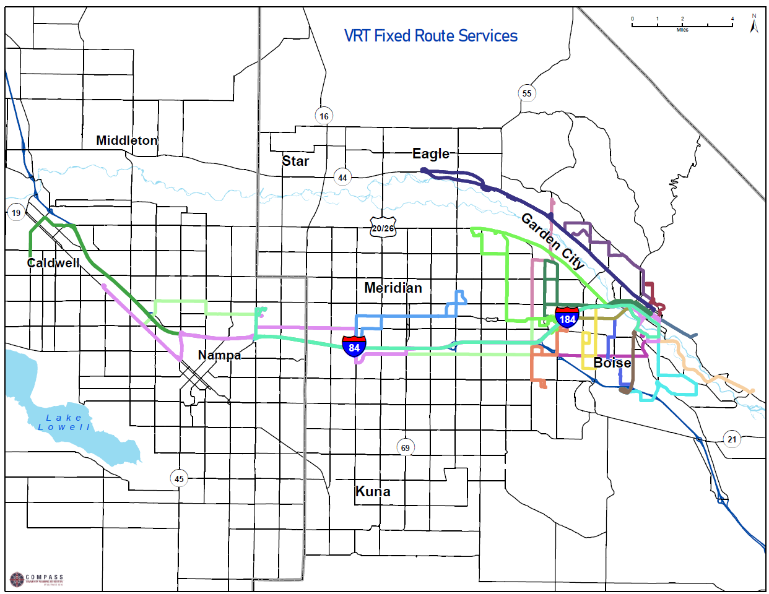
Figure 1: Shows Valley Regional Transit’s 2022 map of routes in Ada and Canyon Counties. Routes are shown in varying bright colors. The map does not include OnDemand bus service area.

To fill gaps in service, VRT implemented the following programs:
- VRT Late Night: Qualified low-income residents can get $3 Lyft rides from 9pm to 6am (hours outside of public bus service). Costs that exceed $23 are the rider's responsibility. Riders are qualified by first verifying their income then receiving a promotional code (Figure 2).
- Lyft Transit Connections: Riders may travel to a VRT bus stop via Lyft for $2. Costs that exceed $8 are the rider’s responsibility. This service is only available in a portion of Garden City and Boise (Figure 2).
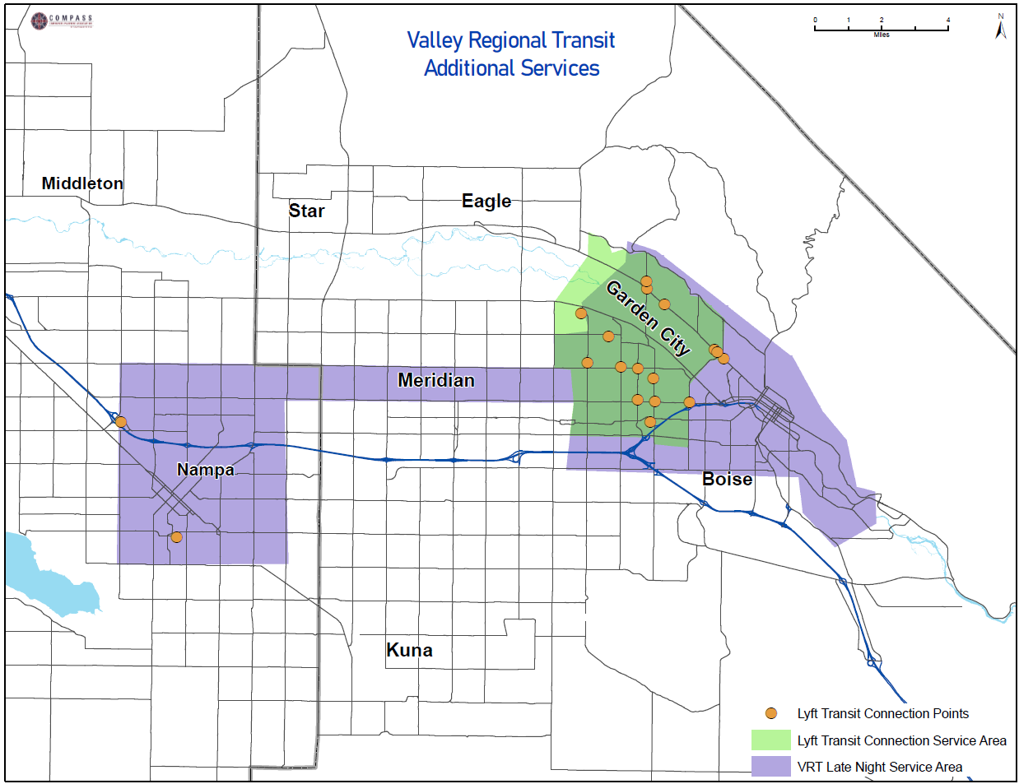
Figure 2: Shows VRT’s Late Night service area in Nampa, Meridian, and Boise purple and the Lyft Transit Connections service area in Garden City and Boise in green. Stops that apply for the Lyft Transit Connections program in Nampa, Boise, and Garden City are shown in orange.

Specialized Transportation
VRT use a portion of 5310 funds to contract with private companies or non-profits to “acquire” service. These programs are called Acquisition of Service (or AOS) programs. AOS programs are included under the service category of “specialized transportation” service, which seeks to fill gaps that are not addressed by fixed route or other demand-response services like ACCESS and OnDemand services. The primary objective of specialized transportation is to optimize financial, human, technical, and equipment resources and expand access to transportation for vulnerable populations. Over the years, those programs have evolved into services for older adults, persons with disabilities, veterans, refugees, and populations with low incomes. Many specialized services provide non-emergency medical transport (or NEMT) (Figure 3). More information on VRT’s specialized transportation programs is included in Appendix A.
While services are provided through independent service providers, VRT assists with training, insurance, coordination, and grant application activities. Annual ridership for specialized transportation programs peaked in Fiscal Year 2019 at 87,502 annual boardings. During COVID-19 many programs suspended service and ridership fell to under 60,000 in Fiscal Year 2020.
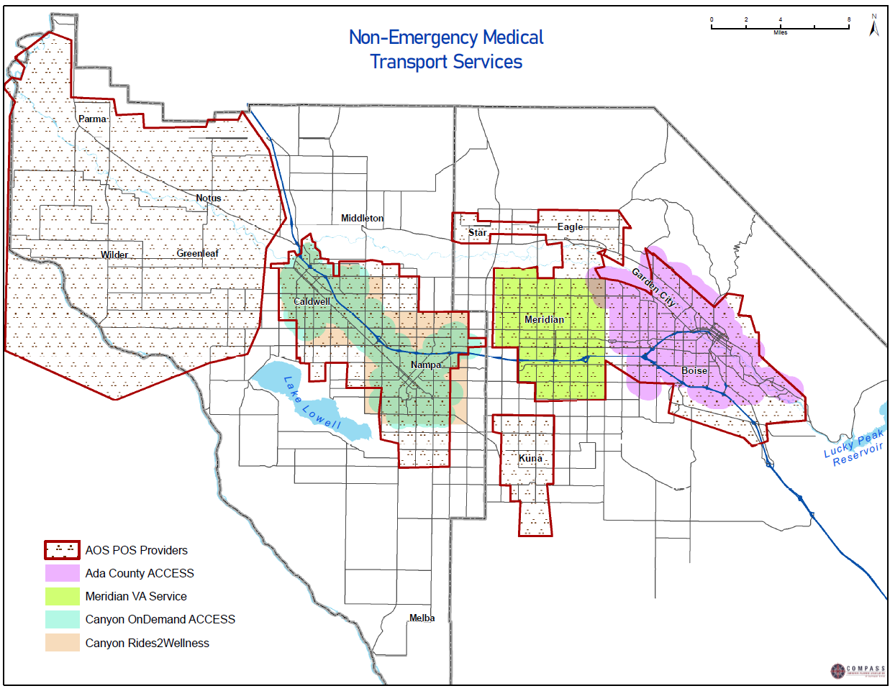
Figure 3: Shows the service area for non-emergency medical transport services in Ada and Canyon Counties. These services include transportation services operated by senior homes, among others.
Most specialized service trips are clustered around fixed routes, with a smattering of trips provided in outer lying areas. The location where trips are requested (trip origins) and where riders want to go (trip destinations) do not significantly differ (Figure 4 and Figure 5). Some trips fall outside the service area and point to a growing need for service boundaries to extend to those areas. For example, the City of Middleton does not fall inside the service boundaries, but there is a relatively high number of rides provided to residents in the city.

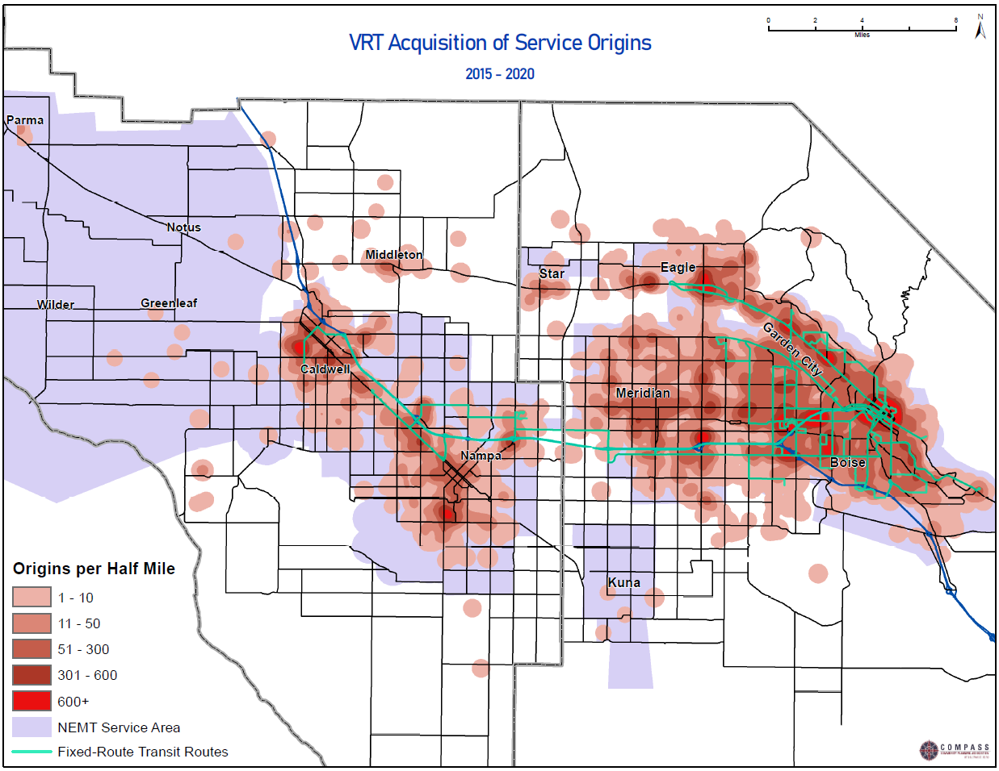
Figure 4: Shows the non-emergency medical transport service area, or NEMT, along with the origin location of all trips taken using these services from 2015 to 2020. Note: The non-emergency medical transport service area shows the combined service areas of Parma, Eagle, Meridian, Star, and Kuna Senior Centers as well as SHIP, Metro, and Harvest transit services, Ada County ACCESS, Canyon County OnDemand, Canyon County ACCESS, Canyon County Rides to Wellness, and VRT Late Night (detailed description of programs below).
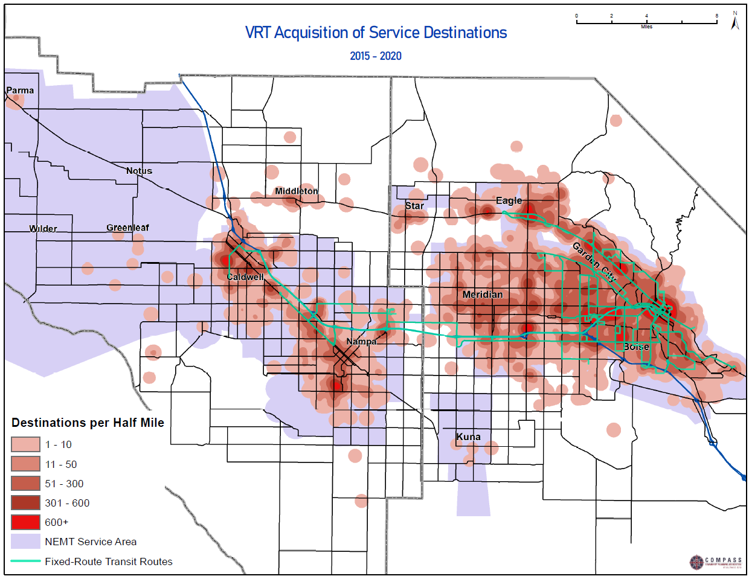
Figure 5: Shows the non-emergency medical transport service area, or NEMT, along with the destination location of all trips taken using these services from 2015 to 2020. Note: The non-emergency medical transport service area shows the combined service areas of Parma, Eagle, Meridian, Star, and Kuna Senior Centers as well as SHIP, Metro, and Harvest transit services, Ada County ACCESS, Canyon County OnDemand, Canyon County ACCESS, Canyon County Rides to Wellness, and VRT Late Night (detailed description of programs below).

Senior Center-Contracted Shuttle Services:
Senior centers contract with VRT for use of their accessible and non-accessible vehicles as well as support services. The following senior centers have active contracts with VRT:
  - Eagle Community and Senior Center:
    - Free rides are available 9:00am to 5:00pm Monday to Friday for seniors and persons with disabilities within the Eagle city limits. Four vehicles in total, with three being accessible.
  - Kuna Senior Center:
    - Free rides are available upon request Monday to Friday for members and others in the area. One accessible vehicle.

  - Meridian Senior Center:
    - Free rides are available upon request Monday to Friday for mainly members of the senior center. One accessible vehicle.
  - Parma Area Senior Center:
    - Free rides are available 8:00am to 2:00pm Monday to Friday for seniors and persons with disabilities in the Cities of Parma, Notus, Wilder, Homedale, and surrounding rural areas. One accessible vehicle.
  - Star Senior Center:
    - Free rides are available upon request Tuesday to Friday for members and others in the Star and Eagle area. One accessible vehicle.

Non-profit-Contracted Shuttle Services:
Non-profits contract with VRT for use of their accessible and non-accessible vehicles as well as support services. The following non-profits have active contracts with VRT:
- Harvest Transit:
  - Free rides are available 9:00am to 3:00pm Monday to Saturday for seniors and persons with disabilities within the city limits of Meridian. Three accessible vehicles.
- Metro Community Services:
  - Free rides are available 6:00am to 5:00pm Monday to Friday for seniors and persons with disabilities within the Cities of Caldwell, Nampa, and Middleton. Rides for residents in smaller communities in Canyon County are available upon request. Five vehicles in total, with two being accessible.
- Supportive Housing and Innovative Partnerships (SHIP):
  - Free rides are available 7:00am to 6:00pm Monday to Friday for seniors, persons with disabilities, and veterans within the city limits of Boise. Four vehicles with three being accessible.

Non-profit Service Providers
- Treasure Valley Transit (TVT) Services:
  - TVT is a non-profit service provider for Medical Transportation Management (MTM) (see “public-private partnerships,” below, for more on MTM). Services are only available in Canyon County. Rides are free for Medicaid participants, but all other riders are charged per mile. TVT coordinates with VRT on service provision.
- Grocery Store Shuttle:
  - The Boise Rescue Mission, St. Luke's Health System, and Saint Alphonsus Health System support a free shuttle to WinCo and Walmart grocery stores each Saturday in the City of Nampa. The program has been running since February 2018. VRT stores the shuttles used for this service at the Happy Day Transit Center.
- Saint Alphonsus Mercy Express Van:
  - Saint Alphonsus operates a free transportation service for Nampa area residents to and from Nampa medical clinics only. Riders need to call 48 hours in advance.

Public-Private Partnerships
Both the Idaho Department of Health and Welfare and VRT use public-private partnerships to provide NEMT services.
- MTM is a private company that acts as Idaho’s NEMT broker. Medicaid participants set up appointments through MTM who, in turn, subcontracts with service providers.
- Rides 2 Wellness is a curb-to-curb transportation service for residents in Ada and Canyon Counties to get to and from medical appointments. Riders must book their rides through VRT who, in turn, schedules the ride with an available private provider. Rides 2 Wellness is a public/private collaborative between NEMT service companies, VRT, and participating hospitals (currently St. Luke's, Saint Alphonsus, and Saltzer Medical). Funding comes from VRT, participating hospitals and clinics, and federal grants. Hours of operation are 7:30am to 6:00pm weekdays.

Private Providers
Many private companies operate emergency and NEMT in the region. Only private companies that partner with public agencies to provide services are listed in this plan. In 2022, VRT maintained contracts with the following companies:
- Trinity Transport
- Your Best Now
- All City Transport

Municipal Services
Some cities have invested tax dollars into providing transportation options for elderly or disabled individuals within their city boundaries. Services include:
- ACCESS: VRT operates a curb-to-curb paratransit service for those who are unable to use the VRT fixed-route and on-demand bus systems due to a disability. Stop locations must be within ¾ mile of a VRT fixed route. The service is funded with tax dollars from the Cities of Boise, Garden City, Nampa, and Caldwell; therefore, only residents with disabilities from those cities can use this service. Trips cost $3 and are available Monday to Saturday in Boise and Garden City and Monday to Friday in Nampa and Caldwell.
- SCRIP: SCRIP is a subsidized taxi service, only available in the City of Boise. Anyone age 15 or older with a permanent disability is eligible to buy six rides for $42.
- Meridian VA Shuttle: The Meridian Veterans Shuttle is a curb-to-curb transportation service for veterans living in the City of Meridian to get to and from appointments at the Boise Veterans Medical Center. Trips are free and are available Monday to Friday from 7:00am to 5:30pm.

Volunteer Services
Volunteer services use qualified volunteer drivers to provide services to individuals in need of transportation. There are two volunteer driver programs in the region:
- VRT Volunteer Driver Program:
  - Certified volunteer drivers give rides to older adults and persons with disabilities. Rides cost $5 per 12-mile segment and $0.50 per additional mile. Trips are available 24/7, but contingent upon driver availability.
- Disabled American Vets Transport:
  - Volunteers provide free rides for veterans. The service is based at the Boise Veterans Medical Center and operates Monday to Friday in the City of Boise and Monday to Wednesday in the City of Nampa. The service stops taking requests at 1:00pm each day.

Refugee Services
One local non-profit agency and VRT operate programs designed to provide refugees transport to essential services.
- Agency for New Americans:
  - Volunteers provide rides for newly arrived refugees for up to two weeks when they first arrive in Idaho
- Village Van:
  - Employers contract with VRT to provide low-income individuals and refugees access to jobs. It operates in Ada County seven days a week.

Commuter Services

Rideshare and Vanpool
Two public agencies provide rideshare services in the Treasure Valley.
- Boise State Carpool: Boise State University students can purchase a carpool parking pass for $320 annually. This pass is only applicable for one vehicle. Benefits include a discounted parking fee and access to designated carpool parking stalls. To qualify for the carpool permit, students must have relatively similar class schedules.
- ACHD Commuteride: Ada County Highway District (ACHD) manages and operates the Commuteride program. ACHD Commuteride’s Club Red Vanpool Program provides vanpool transportation for commuters across the Treasure Valley. Commuteride’s vanpool routes serve multiple employment areas including Downtown Boise, South Boise, Bogus Basin Recreation Area, and the region’s military bases.
  - Club Red Vanpool: Five or more people with a similar commute create a vanpool with a volunteer driver. Vanpool participants pay a monthly fixed rate based on their van’s daily round-trip miles and the average number of days commuting per month. Many employers subsidize the cost of vanpooling as part of their transportation benefit program.

Transportation Management Association
CityGo is the Transportation Management Association for downtown Boise. It provides discounted group rates and incentives to its members; as well as helps coordinate public transportation services.
  - City Go Wallet: An integrated fare system for VRT, ACHD Commuteride, and other public transit services.
  - Member Services: Discounted vanpool rates, bike rental rates, and parking passes to incentivize smart commute practices in downtown Boise.
  - Corporate Member Program: A personalized transit package for employees of member companies.

Park and Ride
There are 15 designated park and ride locations in Ada and Canyon Counties that support ridesharing and transit access. With the exception of the Elder Street Park and Ride, all parking is provided for free to commuters. Locations are managed by ACHD Commuteride, ITD, VRT, and others. In 2021, the COMPASS Regional Park and Ride Study analyzed existing park and ride locations and identified potential for expanded connections (Figure 6).

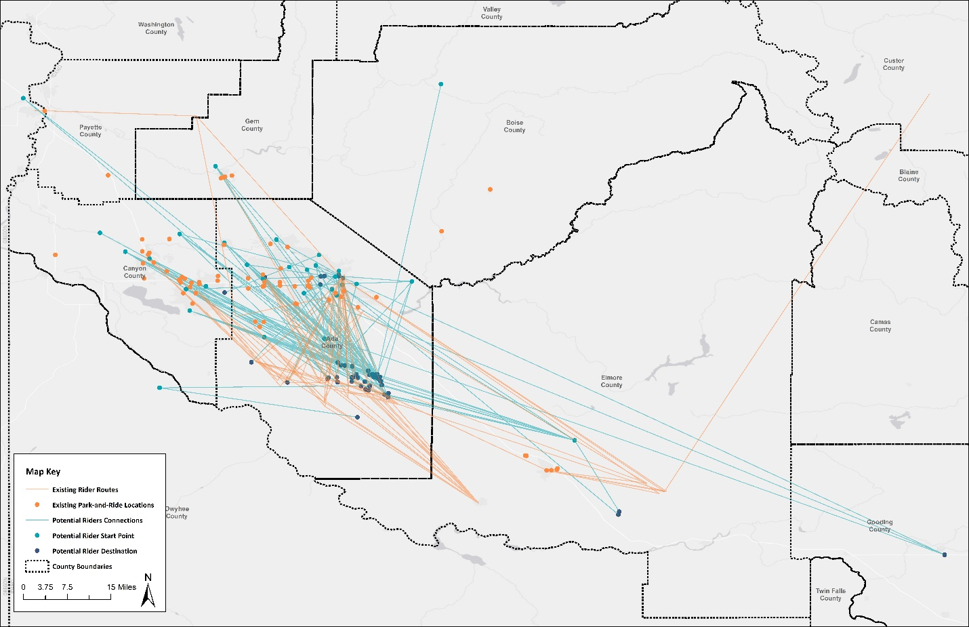
Figure 6: Shows Park and Ride locations with existing routes in orange and potential routes in blue.

Schools and Educational Institutions
Education-focused transportation services in Ada and Canyon Counties include both independent and school-contracted operators.

Independent Operators
- Boise State University provides the Bronco Shuttle, a loop shuttle service on the Boise State University campus, as well as a carpool matching program and promotion of other transportation alternatives such as bicycling, car-sharing (through the private company Zipcar), and public transit. The university also provides a guaranteed ride home program.
- Kuna School District, Melba School District, Notus School District, and Parma School District operate their own bus service for students in the Parma School District.

School-Contracted Operators
- Boise Shuttle Service is a private operator that operates a loop route on the Boise State University campus.
- Brown Bus Company is a private school bus operator that services the Nampa, Vallivue, and Wilder School Districts as well as various charter schools.
- Cascade Student Transportation is a private school bus operator that services the West Ada School District.
- Caldwell Transportation is a private school bus operator that services the Caldwell and Middleton School Districts as well as various charter schools.
- Durham School Services is a private school bus operator that services the Boise Independent School District.

Long-Distance Transit Operators
Five for-profit inter-city bus carriers serve the Treasure Valley.
- Greyhound stops in Boise and Nampa on its route between Portland, Oregon, and Salt Lake City, Utah. The Greyhound route makes two round trips per day. ADA equipped vehicles are available upon request.
- Northwestern Stage Lines provides services between Boise and Coeur d’Alene. This Northwestern Stage Lines route makes one round trip daily. ADA equipped vehicles are available upon request.
- Salt Lake Express operates service from the Boise Airport to Idaho Falls and Salt Lake City, Utah. This route makes two round trips per day, and also stops in Mountain Home. ADA equipped vehicles are available upon request.
- Caldwell Transportation Company offers rental transportation service for large groups and events, such as holiday events, corporate charters, Idaho Wine Tours, and large events and conference shuttles. Vehicle types available include school buses, shuttle vans, and motor coaches. ADA equipped vehicles are available upon request.
- Sun Valley Express is a designated route run by Caldwell Transportation Company that provides services between the Boise Airport and Sun Valley. The Sun Valley Express makes one round trip daily. ADA equipped vehicles are available upon request.

Taxi and Rideshare Companies
Approximately 20 providers of taxi services served Ada and Canyon Counties in 2021, down from approximately 40 in 2014. The decline of taxi services is largely due to the growing popularity of rideshare services. Rideshare services match passengers with drivers who work as contractors for the rideshare company and charge a fee to transport passengers. Two well-known rideshare companies operating in the Treasure Valley are Uber and Lyft.

Lyft currently works with VRT through the VRT Late Night and Lyft Transit Connections program.

Chapter 3 | Demographic Changes
The Treasure Valley is one of the fastest growing areas in the nation. As the region grows, the need for expanded public transportation services for underserved populations is also growing. This section identifies demographic changes of target populations in Ada and Canyon Counties from 2010 to 2019. This information is critical in analyzing potential growth in demand for public transportation. Information in this chapter is summarized in Part 1, Existing Conditions. All data cited in this section is from the 2010 and 2019 American Communities Survey (ACS). At the time this report was written, 2019 ACS data were the most recent data available.

Population Growth
Ada County is the most populous county in Idaho with 481,587 people in 2019. Similarly, Canyon County is the second-most populous county in Idaho with 229,849 people. Together, in 2019 the two-county region had an estimated population of 711,436.
The region has experienced significant population growth over the last nine years. From 2010 to 2019, population grew in Ada County by 22% and Canyon County by 21% (refer to Table 1).

Table 1: Total Population (2010 to 2019)
393,531 people in Ada County in 2010 | 189,428 people in Canyon County in 2010 | 582,959 people in the 2-county region in 2010
481,587 people in Ada County in 2019 | 229,849 people in Canyon County in 2019 | 711,436 people in the 2-county region in 2019
88,056 more people in Ada County in 2019 than 2010 (22% increase) | 40,421 more people in Canyon County in 2019 than 2010 (21% increase) | 128,477 more people in the 2-county region in 2019 than 2010 (22% increase)
Source: ACS 2010, 2019 1-year Estimates

Population density shows the areas that are most likely to need transportation services. In the Treasure Valley, population is concentrated in city centers, but there are also large swaths of medium density areas throughout the region. The population of Ada County is relatively concentrated, while Canyon County’s population is more widely dispersed. To show relative population densities, COMPASS traffic analysis zones are used instead of census blocks.

Disability
A disability may cause an individual to have some level of transportation dependency. From 2010 to 2019, the overall population of individuals with disabilities increased from 10% of the total population (62,055 people) to 12% (87,318 people); or by 25,263 of people ages 5 and above (refer to Table 4).
Region-wide, the number of individuals with disabilities has increased, with the biggest gains in the 65 years old and above population. Ada County has more seniors with disabilities (20,388 people) than Canyon County (15,040 people).
From 2010 to 2019, the share of older adults, who are 65 years old and older, with a disability grew faster in Canyon County (90%) than Ada County (42%) (refer to Table 2 and 3). This means that this population more than doubled in Canyon County.
Ada County saw lower rates of growth for older individuals with disabilities, but also saw fairly high growth in the number of younger (18 to 64) low-income individuals with a disability.

Table 2: Ada County Population of Individuals with Disabilities (2010 to 2019)
2,884 people ages 5 to 17 with a disability in Ada County 2010 (4% of age group) | 18,991 people ages 18 to 64 with a disability in Ada County in 2010 (8% of the total population) | 14,400 people ages 65 and above with a disability in Ada County in 2010 (34% of age group)
3,350 people ages 5 to 17 with a disability in Ada County in 2019 (4% of age group) | 26,722 people ages 18 to 64 with a disability in Ada County in 2019 (9% of age group) | 20,388 people ages 65 and above with a disability in Ada County in 2019 (9% of age group)
466 more people ages 5 to 17 with a disability in Ada County in 2019 than 2010 (16% increase) | 7,731 more people ages 18 to 64 with a disability in Ada County in 2019 than 2010 (41% increase) | 5,988 more people ages 65 and above with a disability in Ada County in 2019 than 2010 (42% increase)
Source: ACS 2010, 2019 1-year Estimates

Table 3: Canyon County Population of Individuals with Disabilities (2010 to 2019)
2,967 people ages 5 to 17 with a disability in Canyon County in 2010 (7% of the total population) | 14,917 people ages 18 to 64 with a disability in Canyon County in 2010 (14% of the total population) | 7,896 people ages 65 and above with a disability in Canyon County in 2010 (38% of age group)
3,216 people ages 5 to 17 with a disability in Canyon County in 2019 (7% of age group) | 18,602 people ages 18 to 64 with a disability in Canyon County in 2019 (14% of age group) | 15,040 people ages 65 and above with a disability in Canyon County in 2019 (46% of age group)
249 more people ages 5 to 17 with a disability in Canyon County in 2019 than 2010 (8% increase) | 3,685 more people ages 18 to 64 with a disability in Canyon County in 2019 than 2010 (25% increase) | 7,144 more people ages 65 and above with a disability in Canyon County in 2019 than 2010 (90% increase)
Source: ACS 2010, 2019 1-year Estimates

Table 4: Ada and Canyon County Population of Individuals with Disabilities (2010 to 2019)
5,851 people ages 5 to 17 with a disability in Ada and Canyon Counties in 2010 (5% of age group) | 33,908 people ages 18 to 64 with a disability in Ada and Canyon Counties in 2010 (9% of age group) | 22,296 people ages 65 and above with a disability in Ada and Canyon Counties in 2010 (35% of age group)
6,566 people ages 5 to 17 with a disability in Ada and Canyon Counties in 2019 (5% of age group) | 45,324 people ages 18 to 64 with a disability in Ada and Canyon Counties in 2019 (11% of age group) | 35,428 people ages 65 and above with a disability in Ada and Canyon Counties in 2019 (34% of age group)
715 more people ages 5 to 17 with a disability in Ada and Canyon Counties in 2019 than in 2010 (12% increase) | 11,416 more people ages 18 to 64 with a disability in Ada and Canyon Counties in 2019 than in 2010 (34% increase) | 13,132 more people ages 65 and above with a disability in Ada and Canyon Counties in 2019 than in 2010 (59% increase)
Source: ACS 2010, 2019 1-year Estimates
Across the region, the percentage of persons with disabilities living in poverty decreased. However, the number and percentage of younger low-income individuals with disabilities increased in Ada County while the number and percent of older low-income individuals with disabilities in Canyon County increased (refer to Table 5 and 6).

Table 5: Ada County Population of Individuals with Disabilities Living in Poverty (2010 to 2019)
548 people ages 5 to 17 with a disability living in poverty in Ada County in 2010 (19% of age group) | 5,173 people ages 18 to 64 with a disability living in poverty in Ada County in 2010 (27% of age group) | 3,896 people ages 65 and above with a disability living in poverty in Ada County in 2010 (27% of the age group)
361 people ages 5 to 17 with a disability living in poverty in Ada County in 2019 (11% of age group) | 7,435 people ages 18 to 64 with a disability living in poverty in Ada County in 2019 (28% of age group) | 1,552 people ages 65 and above with a disability living in poverty in Ada County in 2019 (8% of age group)
187 fewer people ages 5 to 17 with a disability living in poverty in Ada County in 2019 than in 2010 (34% decrease) | 2,262 more people ages 18 to 64 with a disability living in poverty in Ada County in 2019 than in 2010 (44% increase) | 2,344 fewer people ages 65 and above with a disability living in poverty in Ada County in 2019 than in 2010 (60% decrease)
Source: ACS 2010, 2019 1-year Estimates

Table 6: Canyon County Population of Individuals with Disabilities Living in Poverty (2010 to 2019)
737 people ages 5 to 17 with a disability living in poverty in Canyon County in 2010 (25% of age group) | 4,848 people ages 18 to 64 with a disability living in poverty in Canyon County in 2010 (32% of age group) | 706 people ages 65 and above with a disability living in poverty in Canyon County in 2010 (9% of age group)
325 people ages 5 to 17 with a disability living in poverty in Canyon County in 2019 (10% of age group) | 3,932 people ages 18 to 64 with a disability living in poverty in Canyon County in 2019 (21% of age group) | 1,263 people ages 65 and above with a disability living in poverty in Canyon County in 2019 (8% of age group)
412 fewer people ages 5 to 17 with a disability living in poverty in Canyon County in 2019 than in 2010 (56% decrease) | 916 fewer people ages 18 to 64 with a disability living in poverty in Canyon County in 2019 than in 2010 (19% decrease) | 557 more people ages 65 and above with a disability living in poverty in Canyon County in 2019 than in 2010 (79% increase)
Source: ACS 2010, 2019 1-year Estimates

Table 7: Ada and Canyon County Population of Individuals with Disabilities Living in Poverty (2010 to 2019)
1,285 people ages 5 to 17 with a disability living in poverty in Ada and Canyon Counties in 2010 (22% of age group) | 10,021 people ages 18 to 64 with a disability living in poverty in Ada and Canyon Counties in 2010 (30% of age group) | 13,917 people ages 65 and above with a disability living in poverty in Ada and Canyon Counties in 2010 (62% of age group)
686 people ages 5 to 17 with a disability living in poverty in Ada and Canyon Counties in 2019 (10% of age group) | 11,367 people ages 18 to 64 with a disability living in poverty in Ada and Canyon Counties in 2019 (25% of age group) | 12,919 people ages 65 and above with a disability living in poverty in Ada and Canyon Counties in 2019 (36% of age group)
599 fewer people ages 5 to 17 with a disability living in poverty in Ada and Canyon Counties in 2019 than 2010(47% decrease) | 1,346 more people ages 18 to 64 with a disability living in poverty in Ada and Canyon Counties in 2019 than 2010 (13% increase) | 998 fewer people ages 65 and above with a disability living in poverty in Ada and Canyon Counties in 2019 than 2010 (7% decrease)
Source: ACS 2010, 2019 1-year Estimates

Relative to total population, a high number of persons with disabilities live in rural areas without many public transportation options (Figure 7).
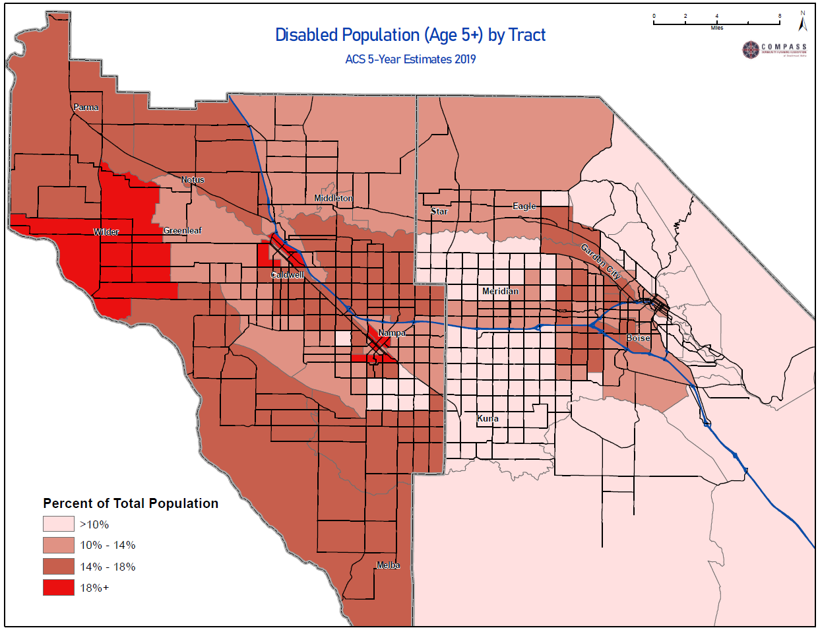
Figure 7: Map showing the percentage of the population, ages 5 and older, with a disability. Areas with more persons with disabilities as a percent of total population, are shown in darker red colors. Data used are from the ACS 5-year estimates in 2019.
The increasing number of people with disabilities in the Treasure Valley highlights a growing need for accessible public transportation options. Additionally, some seniors may not be “disabled,” but still have trouble driving. The combined growth of populations of older adults and individuals with disabilities has implications for changes and expansions of the Treasure Valley’s transportation system.

Limited English Proficiency
From 2010 to 2019, the total number of individuals who speak English less than “very well” decreased from 12,618 to 10,733, a region-wide decrease of about 1,885 people (refer to Tables 8 and 9). However, older persons who speak English “not well” or “not at all” increased from 2010 to 2019 (refer to Table 10). This population is partially made up of resettled refugees. From 2010 to 2020, there were 2,720 refugees resettled in the region. This data is from staff at the Idaho Office for Refugees.

Table 8: Ada County Population who speaks English "not well" or "not at all"
(2010 to 2019)
880 people ages 5 to 17 in Ada County who do not speak English well in 2010 | 3,066 people ages 18 to 64 in Ada County who do not speak English well in 2010 | 705 people ages 65 and above in Ada County who do not speak English well in 2010
293 people ages 5 to 17 in Ada County who do not speak English well in 2019 | 2,792 people ages 18 to 64 in Ada County who do not speak English well in 2019 | 869 people ages 65 and above in Ada County who do not speak English well in 2019
587 fewer people ages 5 to 17 in Ada County who do not speak English well in 2019 than in 2010 (67% decrease) | 274 fewer people ages 18 to 64 in Ada County who do not speak English well in 2019 than in 2010 (9% decrease) | 164 more people ages 65 and above in Ada County who do not speak English well in 2019 than in 2010 (23% increase)
Source: ACS 2010, 2019 5-year Estimates

Table 9: Canyon County Population who speaks English "not well" or "not at all"
(2010 to 2019)
663 people ages 5 to 17 in Canyon County who do not speak English well in 2010 | 6,813 people ages 18 to 64 in Canyon County who do not speak English well in 2010 | 491 people ages 65 and above in Canyon County who do not speak English well in 2010
480 people ages 5 to 17 in Canyon County who do not speak English well in 2019 | 5,426 people ages 18 to 64 in Canyon County who do not speak English well in 2019 | 873 people ages 65 and above in Canyon County who do not speak English well in 2019
183 fewer people ages 5 to 17 in Canyon County who do not speak English well in 2019 than in 2010 (28% decrease) | 1387 fewer people ages 18 to 64 in Canyon County who do not speak English well in 2019 than in 2010 (20% decrease) | 382 more people ages 65 and above in Canyon County who do not speak English well in 2019 than in 2010 (78% increase)
Source: ACS 2010, 2019 5-year Estimates

Table 10: Ada and Canyon County Population who speaks English "not well" or "not at all" (2010 to 2019)
1,543 people ages 5 to 17 in Ada and Canyon Counties who do not speak English well in 2010 | 9,879 people ages 18 to 64 in Ada and Canyon Counties who do not speak English well in 2010 | 1,196 people ages 65 and above in Ada and Canyon Counties who do not speak English well in 2010
773 people ages 5 to 17 in Ada and Canyon Counties who do not speak English well in 2019 | 8,218 people ages 18 to 64 in Ada and Canyon Counties who do not speak English well in 2019 | 1,742 people ages 65 and above in Ada and Canyon Counties who do not speak English well in 2019
770 fewer people ages 5 to 17 in Ada and Canyon Counties who do not speak English well in 2019 than in 2010 (50% decrease) | 1661 fewer people ages 18 to 64 in Ada and Canyon Counties who do not speak English well in 2019 than in 2010 (17% decrease) | 546 more people ages 65 and above in Ada and Canyon Counties who do not speak English well in 2019 than in 2010 (46% increase)
Source: ACS 2010, 2019 5-year Estimates

While the population who speak English “not well” or “not at all” is relatively small, they may have a high reliance on public transportation since it may be difficult for this population to receive a driver’s license or purchase a vehicle.

Low Income
The FTA defines a low-income person as one whose household income is at or below the poverty guidelines set by the Department of Health and Human Services. The 2021 federal poverty estimates for the nation range from $12,880 for a one-person household to $44,660 for an eight-person household.
Older adults are the only population group that increased in total number and percent of population in poverty. The percent growth of low-income older adults was especially high in Canyon County at 79% growth over the last 9-years. However, Ada County still has about twice the number of low-income older adults as Canyon County (Figure 8).
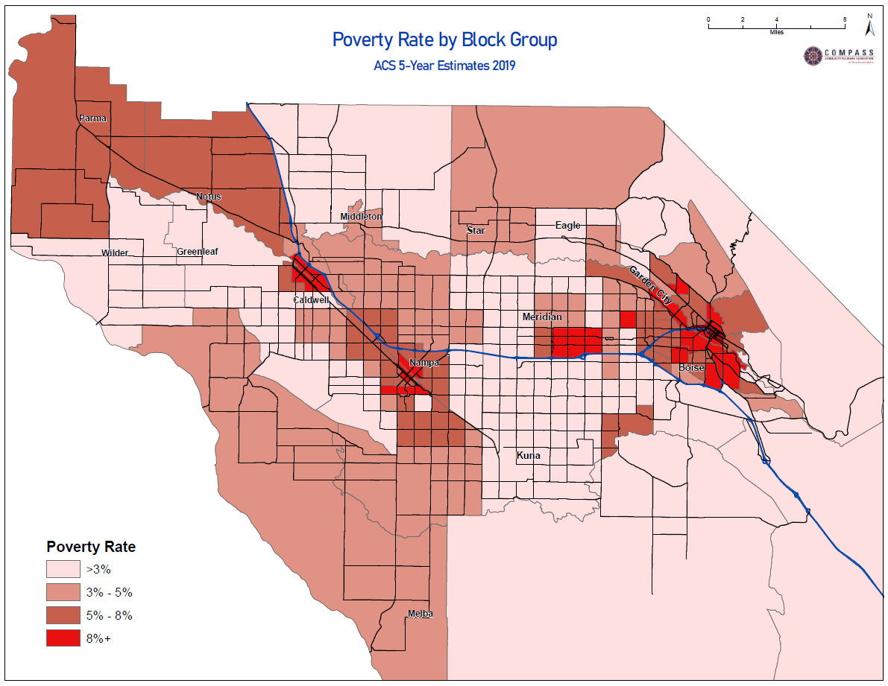
Figure 8: Map showing the poverty rate by block group in 2019. The darker red areas show areas with higher rates of poverty. Data used are from the ACS 5-year estimates in 2019.
From 2010 to 2019, older adults in poverty increased by 856 people (refer to Table 13). Most of the gains occurred in Canyon County whose population of low-income older adults increased by 79%. That said, the total number of older adults in poverty is still much higher in Ada County (3,736) than Canyon County (1,849).

Table 11: Ada County Population in Poverty (2010 to 2019)
10,764 people ages 5 to 17 in Ada County in poverty in 2010 (14% of age group) | 31,481 people ages 18 to 64 in Ada County in poverty in 2010 (13% of age group) | 3,697 people ages 65 and above in Ada County in poverty in 2010 (9% of age group)
8,694 people ages 5 to 17 in Ada County in poverty in 2019 (10% of age group) | 29,911 people ages 18 to 64 in Ada County in poverty in 2019 (10% of age group) | 3,736 people ages 65 and above in Ada County in poverty in 2019 (5% of age group)
2,070 fewer people ages 5 to 17 in Ada County in poverty in 2019 than in 2010 (19% decrease) | 1,570 fewer people ages 18 to 64 in Ada County in poverty in 2019 than in 2010 (5% decrease) | 39 more people ages 65 and above in Ada County in poverty in 2019 than in 2010 (1% increase)
Source: ACS 2010, 2019 1-year Estimates

Table 12: Canyon County Population in Poverty (2010 to 2019)
11,249 people ages 5 to 17 in Canyon County in poverty in 2010 (27% of age group) | 20,933 people ages 18 to 64 in Canyon County in poverty in 2010 (19% of age group) | 1,032 people ages 65 and above in Canyon County in poverty in 2010 (5% of age group)
3,579 people ages 5 to 17 in Canyon County in poverty in 2019 (8% of age group) | 12,411 people ages 18 to 64 in Canyon County in poverty in 2019 (9% of age group) | 1,849 people ages 65 and above in Canyon County in poverty in 2019 (6% of age group)
7,670 fewer people ages 5 to 17 in Canyon County in poverty in 2019 than in 2010 (68% decrease) | 8,522 fewer people ages 18 to 64 in Canyon County in poverty in 2019 than in 2010 (41% decrease) | 817 more people ages 65 and above in Canyon County in poverty in 2019 than in 2010 (79% increase)
Source: ACS 2010, 2019 1-year Estimates

Table 13: Ada and Canyon County Population in Poverty (2010 to 2019)
22,013 people ages 5 to 17 in Ada and Canyon Counties in poverty in 2010 (19% of age group) | 52,414 people ages 18 to 64 in Ada and Canyon Counties in poverty in 2010 (15% of age group) | 4,729 people ages 65 and above in Ada and Canyon Counties in poverty in 2010 (8% of age group)
12,273 people ages 5 to 17 in Ada and Canyon Counties in poverty in 2019 (9% of age group) | 42,322 people ages 18 to 64 in Ada and Canyon Counties in poverty in 2019 (10% of age group) | 5,585 people ages 65 and above in Ada and Canyon Counties in poverty in 2019 (5% of age group)
9,740 fewer people ages 5 to 17 in Ada and Canyon Counties in poverty in 2019 than in 2010 (44% decrease) | 10,092 fewer people ages 18 to 64 in Ada and Canyon Counties in poverty in 2019 than in 2010 (19% decrease) | 856 more people ages 65 and above in Ada and Canyon Counties in poverty in 2019 than in 2010 (18% increase)
Source: ACS 2010, 2019 1-year Estimates
When all adults in poverty ages 18 to 65 years old and older are included, there are about 47,900 low-income adults in the Treasure Valley who may struggle to keep vehicles operational and fueled and thus, may be more reliant upon public transportation options. Low-income people ages 5 to 17 may also rely on public transportation options to travel, especially if their caretakers do not have access to transportation. When this population is added to the low-income adult population, the number of residents who have a higher likelihood of relying on transportation options outside of auto increases to 60,180 in 2019.
Finally, while many older adults may be above federal poverty income thresholds, some still struggle with modest fixed incomes that can impact their transportation choices.

Older Adults (65 years old and older)
FTA guidance defines a senior as an individual who is 65 years old or older. Older adults may have trouble driving and, in some cases, cease driving altogether.
Older adults in the region are growing in both number and share of population. From 2010 to 2019 the 65 years old and older population increased from 62,945 people to 104,186 people. The 65 years old and older age group now makes up 15% of the total population (refer to Table 16). In Ada County the 65 years old and older population grew by 70%. Canyon County grew at a slightly slower rate of 57%.

Table 14: Ada County Population by Age Group (2010 to 2019)
76,345 people ages 5 to 17 in Ada County in 2010 (19% of total population) | 247,531 people ages 18 to 64 in Ada County in 2010 (63% of total population) | 42,108 people ages 65 and above in Ada County in 2010 (11% of total population)
84,474 people ages 5 to 17 in Ada County in 2019 (18% of total population) | 298,325 people ages 18 to 64 in Ada County in 2019 (62% of total population) | 71,534 people ages 65 and above in Ada County in 2019 (15% of total population)
8,129 more people ages 5 to 17 in Ada County in 2019 than 2010 (11% increase) | 50,794 more people ages 18 to 64 in Ada County in 2019 than 2010 (21% increase) | 29,426 more people ages 65 and above in Ada County in 2019 than 2010 (70% increase)
Source: ACS 2010, 2019 1-year Estimates

Table 15: Canyon County Population by Age Group (2010 to 2019)
41,295 people ages 5 to 17 in Canyon County in 2010 (22% of total population) | 110,058 people ages 18 to 64 in Canyon County in 2010 (58% of total population) | 20,837 people ages 65 and above in Canyon County in 2010 (11% of total population)
47,886 people ages 5 to 17 in Canyon County in 2019 (21% of total population) | 132,997 people ages 18 to 64 in Canyon County in 2019 (58% of total population) | 32,652 people ages 65 and above in Canyon County in 2019 (14% of total population)
6,591 more people ages 5 to 17 more people ages 65 and above in Canyon County in 2019 than 2010 (16% increase) | 22,939 more people ages 18 to 64 more people ages 65 and above in Canyon County in 2019 than 2010 (21% increase) | 11,815 more people ages 65 and above more people ages 65 and above in Canyon County in 2019 than 2010 (57% increase)
Source: ACS 2010, 2019 1-year Estimates

Table 16: Ada and Canyon County Population by Age Group (2010 to 2019)
117,640 people ages 5 to 17 in Ada and Canyon Counties in 2010 (20% of total population) | 357,589 people ages 18 to 64 in Ada and Canyon Counties in 2010 (61% of total population) | 62,945 people ages 65 and above in Ada and Canyon Counties in 2010 (11% of total population)
132,360 people ages 5 to 17 in Ada and Canyon Counties in 2019 (19% of total population) | 431,322 people ages 18 to 64 in Ada and Canyon Counties in 2019 (61% of total population) | 104,186 people ages 65 and above in Ada and Canyon Counties in 2019 (15% of total population)
14,720 people ages 5 to 17 in Ada and Canyon Counties in 2019 than 2010 (13% increase) | 73,733 more people ages 18 to 64 in Ada and Canyon Counties in 2019 than 2010 (21% increase) | 41,241 more people ages 65 and above in Ada and Canyon Counties in 2019 than 2010 (66% increase)
Source: ACS 2010, 2019 1-year Estimates
In both Ada and Canyon Counties, there are high concentrations of older adults living in low-density rural areas without significant public transportation options (Figure 9).
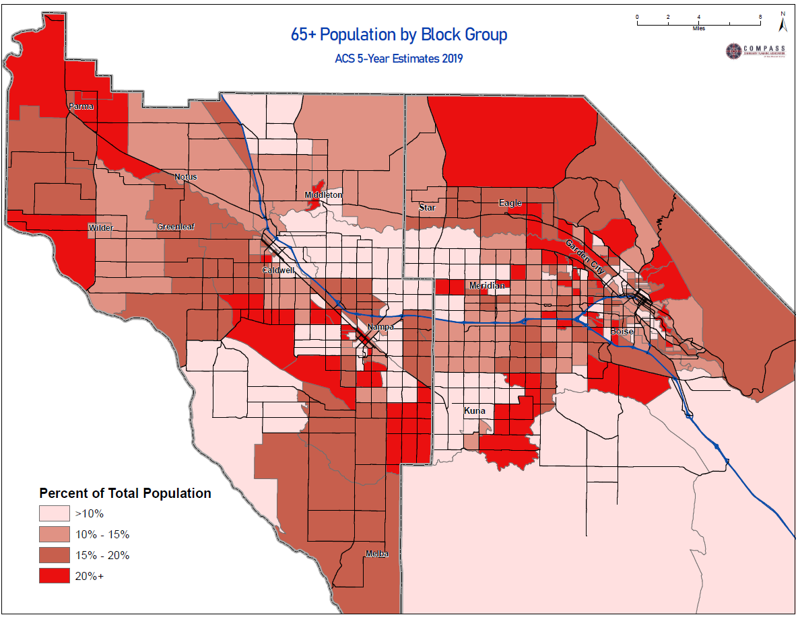
Figure 9: Map showing 65 Years old and older population by Block Group. Darker red areas show areas where there are more older adults. Data used is from the ACS 5-year estimates in 2019.

Autoless Households
While not a target population, households with less than one car per driver (auto-deficit households) are highly correlated with persons with low-incomes, persons with disabilities, and older adults. Since 2010, the number of autoless households decreased in Ada County by 2% but increased in Canyon County by 10% (refer to Table 17). This has significant implications for the public transit system in Canyon County.

Table 17: Households with No Vehicles Available
7,318 households with no vehicles in Ada County in 2010 | 2,962 households with no vehicles in Canyon County in 2010 | 10,280 households with no vehicles in the 2-county region in 2010
7,144 households with no vehicles in Ada County in 2019 | 3,257 households with no vehicles in Canyon County in 2019 | 10,401 households with no vehicles in the 2-county region in 2019
174 fewer households with no vehicles in Ada County in 2019 than 2010 (2% decrease) | 295 more households with no vehicles in Canyon County in 2019 than 2010 (10% increase) | 121 more households with no vehicles in the 2-county region in 2019 than in 2010 (1% increase)
Source: ACS 2010, 2019 1-year Estimates

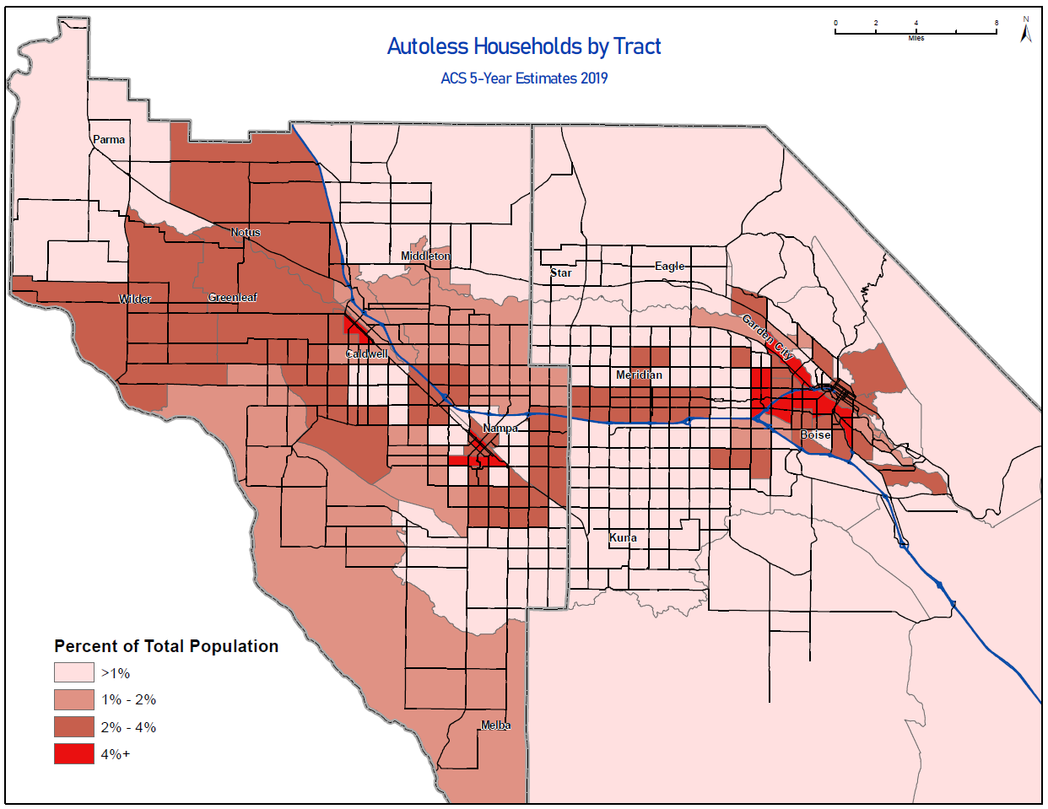
Figure 10: Map showing autoless households by tract. Areas that are darker red show areas where more people do not own a car. Data used is from the ACS 5-year estimates in 2019.

Part 2. Identifying and Addressing Unmet Transportation Needs
Part 2 will address the following federal requirements:
- An assessment of transportation needs for target populations included in the Coordinated Plan.
- Identification of strategies to address the identified gaps between current services and needs.
- Priorities for implementation.
Findings included in the following chapters will guide service improvements for the 5310 program and serve as information to improve coordination of services across the region.

Chapter 4 | Public Survey
From September 15 to October 15, 2021, COMPASS conducted the Transportation Needs Identification Survey, a public survey to identify the unmet transportation needs of persons with disabilities, older adults, persons with limited English proficiency, and persons with low-incomes. The survey was distributed to the following groups:
- Boise Ada Homeless Coalition - virtual meeting and email distribution
- Valley Regional Transit Regional Advisory Council - virtual meeting and email distribution
- Ada County Highway District ADA Advisory Committee - virtual meeting and email distribution
- Idaho Transportation Department District 3 Public Transportation Provider Meeting - virtual meeting and email distribution
- Wilder Housing Authority - hard copy survey materials posted in public areas
- Caldwell Housing Authority - hard copy survey materials posted in public areas
- Informal phone calls to senior homes
Two versions of the survey were distributed. First, the advocate survey, which was a longer and more detailed survey, was distributed to public transportation providers and non-profit community advocates. Second, the stakeholder survey, which was a shorter survey, was distributed to individual stakeholders.
To ensure accessibility, online surveys were available in English and Spanish and accessible via a screen reader. Hard copies were also available in both English and Spanish. The surveys are included in Appendices B and C.
Twenty-six individuals completed the advocate survey, representing the following organizations:
- ACHD Bicycle Advisory Committee
- Charitable Assistance to Community’s Homeless (CATCH)
- Canals Connecting Communities Coalition (CCCC)
- Idaho Commission on Aging
- Idaho Strong – COVID Crisis Response
- Jannus – English Language Center
- Metro Community Services (METRO)
- Nampa’s Bicycle and Pedestrian Advisory Committee
- Parma Senior Citizen Home
- Idaho State Independent Living Council (SILC)
- Treasure Valley Transit (TVT)
- West Ada School District - Special Education

Ten individuals completed the stakeholder survey.
- 46% of respondents identified as having a disability
- 23% of respondents identified as having low-income
- 16% identified as an older adult
15% identified as having limited English proficiency.

Chapter 5 | Unmet Transportation Needs, Priorities, and Strategies
This section identifies unmet regional transportation needs and corresponding priorities and strategies to address them.
An unmet transportation need is a barrier that stops or hinders persons with disabilities, older adults, persons with low-incomes, and/or persons with limited English proficiency from getting to their desired destinations using public transportation.
A high transportation priority is an unmet transportation need that has been determined to be one of the most pertinent needs to address.
A strategy is a method to address an unmet transportation need.

Public Survey
The Transportation Needs Identification Survey asked participants asked to identify their transportation needs or those of the constituency they represent. Survey results were organized into the following four categories:
- Infrastructure Needs – Defined as needs that relate to maintaining existing or constructing new transportation infrastructure
- Service Needs - Defined as needs that relate to the expansion of public transportation services (including new routes and/or increased frequency or operating hours)
- Customer Service Needs - Defined as needs that relate to customer service provided by transportation operators, including driver behavior and communication with passengers
- Inter-Agency Coordination - Defined as needs that relate to coordination between transportation providers and local land use agencies.
This survey was not intended to be a statistically representative survey, but rather it was meant to learn about unmet transportation needs of target populations in the region. Due to this, a quantitative survey analysis is not included in this plan; only qualitative results.

Detailed Survey Results

#1: Infrastructure Needs from Survey
Survey respondents said:
  - “Sidewalks to stop locations are in bad condition (not cleared of snow, cracked, etc.)”
  - Ramps are "missing, broken, or badly graded”
  - Riders need “bigger font size”
  - Riders need “Bus tracking through the phone, with voice over”
  - Riders need “Clearer information on how to transfer”
  - Riders need “Drivers and who speak their language (i.e.: Spanish, ASL, Farsi, Burmese) or at least information in those languages”
  - There is “limited space for more than one chair user to ride together”
Based on what survey respondents said four needs were identified:
  - Accessible vehicle improvements
  - Accessible bus stop improvements
  - Accessible information improvements
  - Updated scheduling software

#2: Service Needs from Survey
Survey respondents said:
- "We need to be able to be spontaneous and be able to go where we want to go without scheduling 24 hours in advance (minimum)"
- "When it (the bus) stops running at 6 or 7 p.m. they'd get stranded."
- “Limited weekend service”
- "Getting to and from work difficult without a significant amount of time lost for time with family and increasing childcare cost and needs"
- "Missing a bus could jeopardize their job, miss an appointment, or prevent them from being on time to pick up their child from school or daycare."
- “Individuals outside of service area”
- “Accessibility to the surrounding communities. Star, Eagle, Meridian, Kuna, Nampa and Caldwell”
- “Many jobs that pay well do not have a bus route that can take them there”
- “After high school, students who are unable to drive or ride a bike safely are unable to work or access the community in a meaningful way due to a lack of transportation”
- "Even discounted Lyft rides are expensive on fixed income"
- “Access to basic services”
- “Limits work, shopping, recreational opportunities”
- "Seniors have very little stamina due to chronic illness and health concerns and it's hard for them to be all day riding to get where they need to go."
- Needs “reliable (on-time) transportation to and from work”
Based on what survey respondents said nine needs were identified:
- More on-demand services
- Longer service hours
- More frequent service
- Lack of service in rural and suburban areas
- Lack of access to job sites
- Expensive passenger fares
- Lack of access to activity centers
- Long commute times
- Un-reliable service (late)

#3: Customer Service Needs from Survey
Survey respondents said:
- Difficulty getting to parks, gyms, “grocery stores, appointments, lunch and other places in the community.”
- "Cost, confusion, discrimination by drivers and community members against unhoused people"
Based on what survey respondents said two needs were identified:
- Lack of quality-of-life trips
- Driver discrimination

#4: Inter-Agency Needs from Survey
Survey respondents said:
- “Many people are forced to live far from where they work because they cannot afford to live there (Example Boise, Meridian, and Eagle). If they rely on public transit and they are forced to move to an area without adequate public transportation they are faced with the possibility of losing their job"
- “Coordinate with the medical providers to get several people from the same area appts. at the same time or back-to-back.”
- “Few park and ride locations close to affordable housing”
- “We (providers) are going out of our way to service (people), even though they may not be in our boundary”
Based on what survey respondents said four needs were identified:
- Lack of affordable and accessible housing on transit lines
- Lack of coordination between transit with medical providers
- Lack of affordable housing near park and ride locations
- Unclear service areas

Prioritization Process
Federal regulations require that transportation services and projects be prioritized for funding and implementation. Although it is necessary to prioritize strategies and actions based on available resources, this Coordinated Plan does not attempt to dictate which needs and strategies should receive funding. Rather, it identifies set of highest priorities for the Ada and Canyon County region as ranked by RAC members (Table 13). The list of highest priority needs will guide project selection for 5310 funds and inform project selection for other funding sources until the next update of this plan.

Highly Ranked Unmet Transportation Needs
  - Accessible vehicle improvements
  - Accessible bus stop improvements
  - Accessible information
  - Longer service hours
  - More frequent service
  - Lack of service in rural and suburban areas
  - Lack of access to job sites
  - Lack of affordable and accessible housing on transit lines
  - Lack of coordination between transit with medical providers

Medium Ranked Needs Unmet Transportation Needs
  - Scheduling software is not well calibrated to real travel time
  - Expensive passenger fares
  - Lack of access to activity centers
  - Long commute times
  - Un-reliable service (late)
  - Lack of quality-of-life trips
  - Driver discrimination
  - Lack of affordable housing near park and ride locations
  - Unclear service areas

Highest Priority Transportation Needs
Based on the rankings of specific needs identified earlier, seven priority needs were identified and approved by the RAC as the highest priority transportation needs to be addressed in this Coordinated Plan. They are as follows:
- Improve Access to Transit
- Expand Service Hours and Days
- Increase Service Frequency and Availability
- Improve Access to Employment
- Meet Service Needs in Rural and Suburban Areas
- Co-Locate Affordable and Accessible Housing on Transit Lines
- Improve Access to Necessary Social Services and Medical Providers

Strategies to Address Highest Priority Transportation Needs
A set of strategies to address these transportation needs was developed by agency staff at COMPASS and VRT; then reviewed and approved by the RAC. Strategies were developed in coordination with the strategic objectives of the forthcoming VRT Transportation Development Plan (click to link). In this way, the region seeks to coordinate efforts across programs to meet the growing transit needs of the region.
An individual may use either demand-response or fixed route services or both. Thus, to effectively address the needs of all target populations of this plan, strategies are not limited to specialized transportation services but include improvements to fixed-route services. However, when fixed-route service is not a viable alternative, specialized transportation services are especially important.
Highest priority needs and strategies are described on Pages 51 – 52. Note that the numbers are for reference only; they do NOT indicate a priority order of needs. For example, Priority Need #4 is as important as Priority Need #1. Individual projects that meet these needs will be prioritized for funding based on the funding source and specific circumstances of that project.

- Priority Need #1: Improve Access to Transit - This priority focuses on improving target populations’ access to transit service. Strategies to address this need include:
  - Improve infrastructure and transit amenities at bus stop locations to provide lighting, shelter, and accessible pedestrian connections
        - Funding Programs include: 5307, 5310 (Non-Traditional), 5339, Idaho Curb Ramp Program, Transportation Alternatives Program
  - Increase availability of accessible vehicles for demand response services, including specialized transportation
        - Funding Programs include: 5310 (Traditional), 5311, 5339
  - Expand marketing and outreach efforts to ensure residents are aware of transportation options within the region
        - Funding Programs include: 5307, 5310 (Non-Traditional)
  - Expand programs that train people on how to use available transportation options
        - Funding Programs include: 5307, 5310 (Non-Traditional)
- Priority Need #2: Expand Service Hours and Days - This priority focuses on expanding service hours and days for fixed and specialized transit services in the region. Strategies to address this need include:
  - Increase late night service hours
        - Funding Programs include: 5307, 5310 (Non-Traditional)
  - Increase service hours on weekends
        - Funding Programs include: 5307, 5310 (Non-Traditional)
- Priority Need #3: Increase Service Frequency and Availability - This priority focuses on expanding frequency of fixed-route transit and availability of specialized transit services in the region so that individuals have greater access to transit more hours in the day. Strategies to address this need include:
  - Improve the cost-effectiveness of demand response services, including specialized transportation
        - Funding Programs include: 5307
  - Increase revenue hours for demand response services, including specialized transportation
        - Funding Programs include: 5307, 5311
  - Increase availability of qualified transit drivers in the region
        - Funding Programs include: 5307, 5310 (traditional), 5311
  - Invest in “premium” transit services to increase service frequency in key transit corridors
        - Funding Programs include: 5307
  - Invest in “frequent” transit services to increase service frequency in key transit corridors
        - Funding Programs include: 5307
- Priority Need #4: Improve Access to Employment - This priority focuses on expanding access to employment through fixed or specialized transit services in the region. Strategies to address this need include:
  - Increase the frequency of fixed route services and/or the availability of demand-response services to better accommodate individuals who ride public transportation to work
        - Funding Programs include: 5307, 5311
  - Increase evening service hours
        - Funding Programs include: 5307
  - Maintain and expand VRT Late Night and Lyft Transit Connections Programs
        - Funding Programs include: 5307, 5310 (traditional), 5311
  - Work with employers to improve and expand transit services or programs that increase access to places of employment
        - Funding Programs include: 5307, 5311, Transportation Alternatives Program
- Priority Need #5: Meet Service Needs in Rural and Suburban Areas - This priority focuses on expanding fixed or specialized transit services to meet needs in rural and suburban areas. Strategies to address this need include:
  - Increase geographic coverage of demand response services to reach a greater range of locations
        - Funding Programs include: 5307, 5311, 5339, Vehicle Improvement Program, Transportation Alternatives Program
  - Increase the number of fixed route transit connections at Park and Ride locations
        - Funding Programs include: 5307, 5311, 5339, Vehicle Improvement Program, Transportation Alternatives Program
  - Improve infrastructure and transit amenities at existing Park and Ride locations
        - Funding Programs include: 5307, 5311, 5339, Vehicle Improvement Program, Idaho Curb Ramp Program, Transportation Alternatives Program
  - Expand existing intercounty public transportation services
        - Funding Programs include: 5307, 5311, 5339
- Priority Need #6: Co-Locate Affordable and Accessible Housing with Transit Lines - This priority focuses on co-locating affordable and accessible housing with fixed transit lines. Strategies to address this need include:
  - Develop collaborative opportunities with municipalities to locate affordable housing on or near transit routes
        - Funding Programs include various competitive grant opportunities
  - Develop collaborative opportunities with municipalities to locate ADA accessible housing on or near transit routes
        - Funding Programs include various competitive grant opportunities
- Priority Need #7: Improve Access to Necessary Social Services and Medical Providers - This priority focuses on improving scheduling coordination between medical providers and transit services to increase efficiencies. Strategies to address this need include:
  - Improve coordination between transit services and key partners
        - No Funding Programs are identified
  - Optimize routing and appointment times to shorten trips and wait times
        - Funding Programs include: 5307, 5310 (non-traditional), 5311

Chapter 6 | Implementation

Biennial Report
COMPASS will track regional progress toward addressing the highest priority needs identified in the Coordinated Plan. COMPASS, in cooperation with VRT, will analyze the extent to which federal and state funded projects addressed the highest priority needs and track progress toward meeting those needs using on identified performance measures. The results of these analyses will be presented biennially to the RAC. Results of these analyses will also be used to inform future Coordinated Plans.

Performance Measures for the Coordinated Plan
- Need: Improve Accessibility to Transit
  - Performance Measures:
    - Qualitative changes in ADA compliance, Source: Local Agencies
    - Number of transportation vehicles in “good condition”, Source: VRT
    - Annual Boardings, Source: VRT
- Need: Expand Service Hours and Days
  - Performance Measures:
    - Change in annual weekday service hours, Source: VRT
    - Change in annual weekend service hours, Source: VRT
- Need: Increase Service Frequency and Availability
  - Performance Measures:
    - Change in annual service hours at 30-minute frequency or higher, Source: VRT
    - Change in annual coverage (sq miles), Source: VRT
    - Change in drivers available, Source: VRT
- Need: Improve Access to Employment
  - Performance Measures:
    - Change in percentage of employment within ¼-mile walking distance of a bus stop, Source: COMPASS
    - Average number of jobs accessible by transit within 30 minutes on average on weekdays, Source: COMPASS
    - Vanpool monthly ridership, Source: ACHD Commuteride
- Need: Meet Service Needs in Rural and Suburban Areas
  - Performance Measures:
    - Increased annual coverage (square miles), Source: VRT
- Need: Co-Locate Affordable and Accessible Housing on Transit Lines
  - Performance Measures:
    - Due to limited data, affordable and accessible housing will be evaluated using the surrogate measure of change in percentage of total households within ½-mile of a bus stop, Source: Local Agencies
- Need: Improve Access to Necessary Social Services and Medical Providers
  - Performance Measures:
    - Qualitative description of improvements, Source: Local Agencies
    - Activity center access (i.e. key destinations), Source: COMPASS

Chapter 7 | Conclusion
As the population of the Treasure Valley increases, the need for increased public transportation services to meet the needs of underserved individuals continues to grow. The 2022 Coordinated Plan is intended to truly support and improve the coordination of existing and future services, including but not limited to 5310 funds. By addressing needs of underserved populations within the context of all funding sources available this plan seeks to find a way forward to address the region’s growing unmet transportation needs. In addition, this plan also acknowledges that all public transportation services should be considered when planning for individuals needs and includes strategies to address both specialized and fixed-route services. To ensure that the needs of underserved individuals are actively considered, a biennial review process has been developed as part of this plan. These action all seek to improve the services available to underserved populations and ultimately, improve quality of life in the region.

Appendices

Appendix A | Valley Regional Transit Specialized Transportation Analysis: Background and Overview

Existing Services
Seniors and persons with disabilities: The Federal Transit Administration (FTA) established the Section 5310 grant program in 1975 to serve the transportation needs of older adults and persons with disabilities. In 2015, the Fixing America’s Surface Transportation (FAST) Act brought significant changes to the program.
Instead of apportioning funds directly to states, funds were apportioned to large urban, small urban and rural areas. The FAST Act made it possible for Valley Regional Transit (VRT) to work with existing Acquisition of Service (AOS) 5310 grant recipients and establish new non-profit AOS transportation providers. The objective was to facilitate more efficient use of available resources, reduce costs and fill gaps in service for Treasure Valley seniors and persons with disabilities. Program funds support transportation providers by reimbursing costs to deliver service on a per boarding basis. Transportation providers include senior centers and other non-profit agencies.
Transit dependent medical patients: In response to a 2015 federally sponsored initiative, VRT developed Rides 2 Wellness, a public/private collaborative with Boise area hospitals and clinics. Rides 2 Wellness improves community heath by enabling Treasure Valley residents who may otherwise not have transportation to get to follow-up medical appointments and receive treatment. Non-emergency medical transportation (NEMT) service providers deliver the rides.
Volunteer Driver program: The Volunteer Driver program is one of the first Specialized Transportation programs. Funded in part by low, affordable fares, in-kind and federal funds the Volunteer Driver program functions as a safety net for those needing transportation outside the hours or service areas of other fixed line or Specialized Transportation services. Volunteer drivers are recruited, vetted and trained from all across the Treasure Valley.

Specialized Transportation ridership performance
By increasing the number of vehicles, drivers and hours of service, AOS ridership has increased. Demand for rides has disproportionately grown larger than capacity. SHIP Transportation, Harvest Transit, Metro Community Services and Eagle Senior Center have responded by moving excess ride requests to a will call or waiting list. This ultimately ends with trip denials each day. Even with a will-call list, there are not enough cancellations or no-shows to accommodate every ride request.
Specialized transportation programs, including AOS transportation, Rides 2 Wellness and VRT Volunteer Driver programs saw increases in ridership as an outcome of collaboration with VRT:
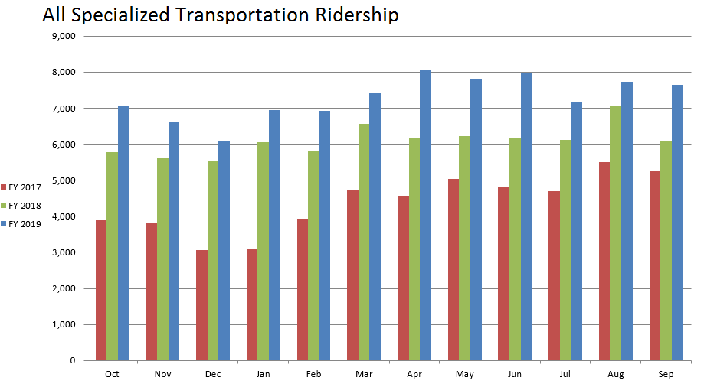
Figure 11: Graph showing all specialized transportation ridership in fiscal years 2017, 2018, 2019. Ridership increased significantly each year. The highest ridership month was April 2019.
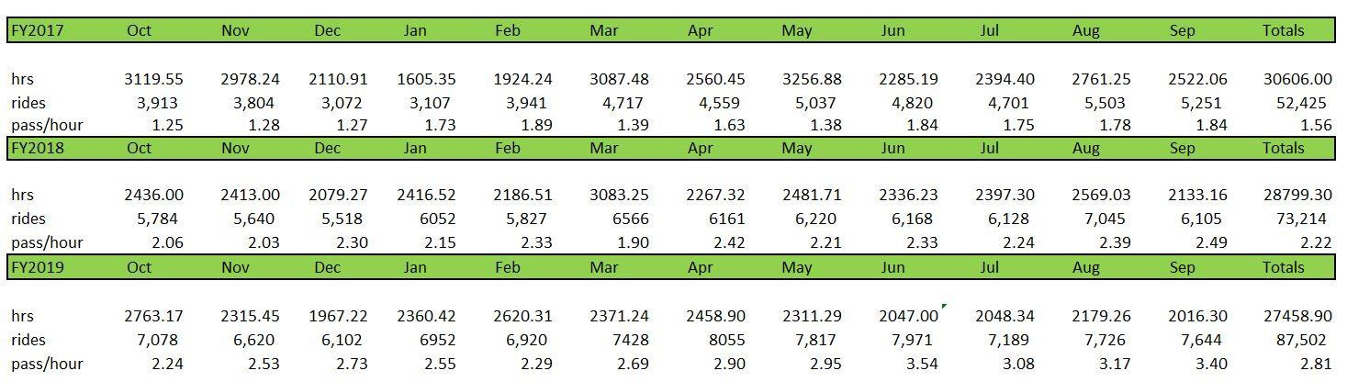
Figure 12: Shows ridership of VRT’s specialized transportation programs in fiscal years 2017, 2018, and 2019. Rides-per- hour increased from 1.56 rides-per-hour in 2017 to 2.81 rides-per-hour in 2019.

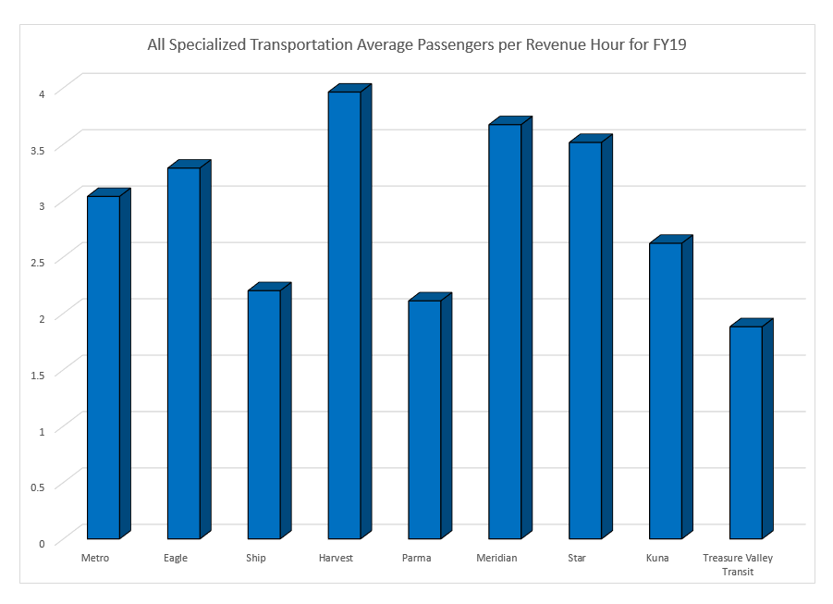
Figure 13: Shows the average number of passengers per revenue hours for different types of services in fiscal year 2019. Passengers per revenue hour ranged from 1.88 for Treasure Valley Transit to 3.96 for Harvest Transit.

Specialized Transportation Program Supports
Shared Vehicle program: VRT makes available to AOS service providers and other qualified non-profit organizations accessible and non-accessible vehicles at a reduced fee. VRT maintains and insures the vehicles as part of the Specialized Transportation pool. Annual state of good repair evaluations track the condition of pool vehicles and plan for vehicle replacements.

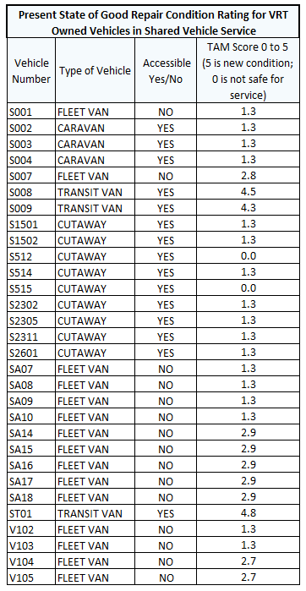
Figure 14: Shows the 2019 rating for all vehicles in the Specialized Transportation vehicle pool. Each vehicle receives a score between 0 to 5. Vehicles with a score of 5 are new vehicles, while scores of 0 show vehicles that are not safe for service. In 2019 VRT had 15 out 30 vehicles with a rating of 1.3 and one vehicle with a score of 0. All other vehicles received higher scores. Note that a vehicle replacement plan is in effect and replacement vehicles have been added since the last rating on vehicles that is shown here was completed.
RouteMatch dispatch and scheduling software: AOS providers are able to optimize schedules and routes, increase passengers per hour, reduce no-shows and minimize driver idle time by collaborating with VRT using RouteMatch scheduling software.
Customer service support: VRT is here to help. Whether it is answering customer inquiries or helping our partners with RouteMatch scheduling related questions, VRT Customer Service department assists all Specialized Transportation service providers.
Training: VRT provides continuous RouteMatch training and on-going driver education.

Transportation provider | Customer service support | RouteMatch technical support | Number of shared vehicles in use | Training
Metro Community Services | X | X | 1 | X
Harvest Transit | X | X | 3 | X
Eagle Community and Senior Center Transportation | X | X | 4 | X
Supportive Housing and Innovative Partnerships (SHIP) Transportation | X | X | 4 | X
Meridian Senior Center | - | - | - | -
Parma Senior Center | - | - | 1 | X
Star Senior Center | - | - | 1 | X
Kuna Senior Center | - | - | - | -
Figure 15: Shows how AOS providers use VRT supports. Specialized transportation providers may use customer service support, RouteMatch technical support, and training. The Idaho Counties Risk Management Program (ICRMP), a member-owned self-insurance pool, currently insures the VRT shared vehicle pool. A significant finding is that as the pool of shared vehicles expands VRT’s risk exposure increases.

Cost comparison to deliver service
From the individual volunteer drivers using their own vehicle to the full service AOS provider with multiple vehicles, the cost to deliver service varies.
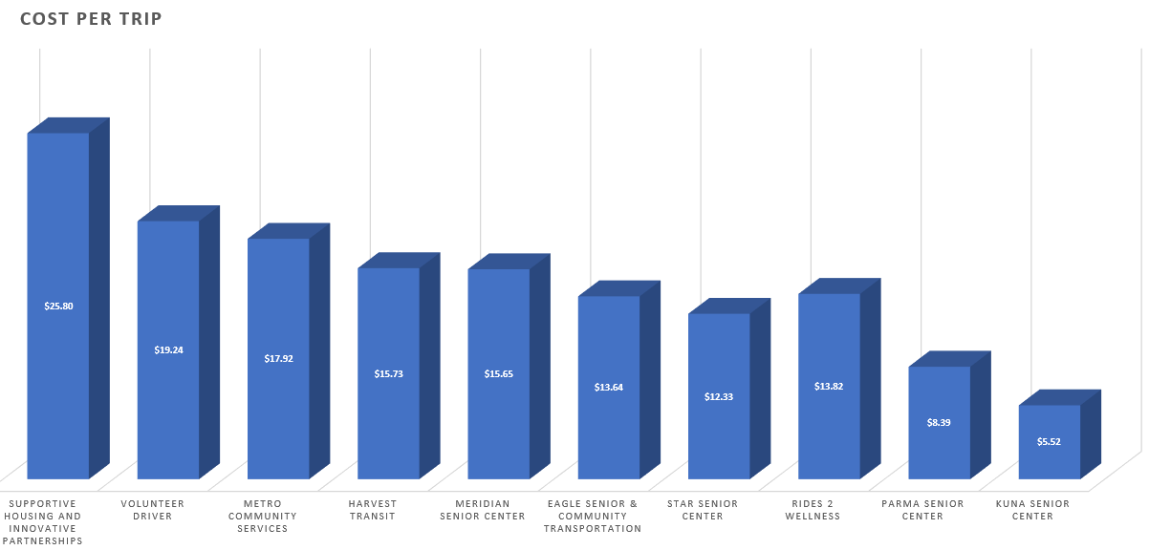
Figure 16: Shows the cost-per-ride by provider or service. Costs per ride vary from $5.52 at Kuna Senior Center to $25.80 at SHIP. Variances are due to a range of factors including the number of volunteers working both as drivers and as supports staff, manual scheduling vs. automated software, and the number of vehicles in service.

Overall findings and recommendations
Following a complete review of the Specialized Transportation programs administered and coordinated by VRT, it is apparent there are areas that need addressed. Some findings will be easy to resolve, such as completing an inventory of missing providers. Some finding will require VRT staff and partners to work together to find a resolution that will meet VRT needs and not be an administrative burden to providers, such as developing consistent processes and tools to assist providers in processing invoices and providing performance data.

Future potential for existing services
Future AOS expansion of service:
- Funding – Service providers must generate the local match requirement to receive federal funds. As AOS provider services continue to grow, more emphasis must be placed on shifting funding sources from 5310 program funds (80 percent federal, 20 percent local match) to 5307 program funds (50 percent federal, 50 percent local match).
- Service providers – Future AOS expansion is dependent on providers that have a vision for serving their customers and communities. Data compiled over the past three years shows that demand for rides increases to meet available service.
- To meet current and future demand - service providers must be willing to grow their service. This includes expanding service to include technology for scheduling and dispatching rides and more cost-effective shared vehicles. With vehicle seating of nine to 14 passengers most service providers have the capacity to deliver two to three times their current ridership.
Rides 2 Wellness future potential
- Ada County and Boise – NEMT provider RAMP IT UP contracted to provide service in Ada County into fiscal Year 2020. Trinity Transportation may also become an Ada County NEMT provider for the program beginning in Fiscal Year 2020. Peer Wellness Center has also expressed an interest in becoming a Rides 2 Wellness and transportation provider as described in Valley Connect 2.0.
- Canyon County – Ramp It Up, Trinity, Peer Wellness Center and Treasure Valley Transit have expressed an interest in expanding business as described in Valley Connect 2.0 and Rides 2 Wellness as programs move into other Treasure Valley communities.
Volunteer driver future potential
- Uber, Lyft and other transportation services has proven the viability of volunteer transportation. New emphasis will be placed on building a large pool of volunteer drivers.

Detailed Specialized Transportation by Program and Provider

Rides 2 Wellness
Rides 2 Wellness serves Ada County patients with medical conditions that have the highest likelihood of developing debilitating and costly complications. Rides 2 Wellness improves community heath by enabling Ada County residents who may otherwise have no other means of transportation to keep their follow-up appointments and receive treatment. Funding for both ambulatory and patients requiring accessible rides is provided by Ada County healthcare systems. The program supports quality healthcare in the region by reducing costs due to missed appointments and hospital readmissions.
Rides 2 Wellness is a public/private collaborative with non-emergency medical transportation (NEMT) providers delivering the rides. Rides 2 Wellness provided 4,702 rides to Boise area patients in fiscal year 2017, 9,151 rides in FY2018, and 10,421 rides in FISCAL YEAR 2019. Efforts are under way to expand service to Canyon County.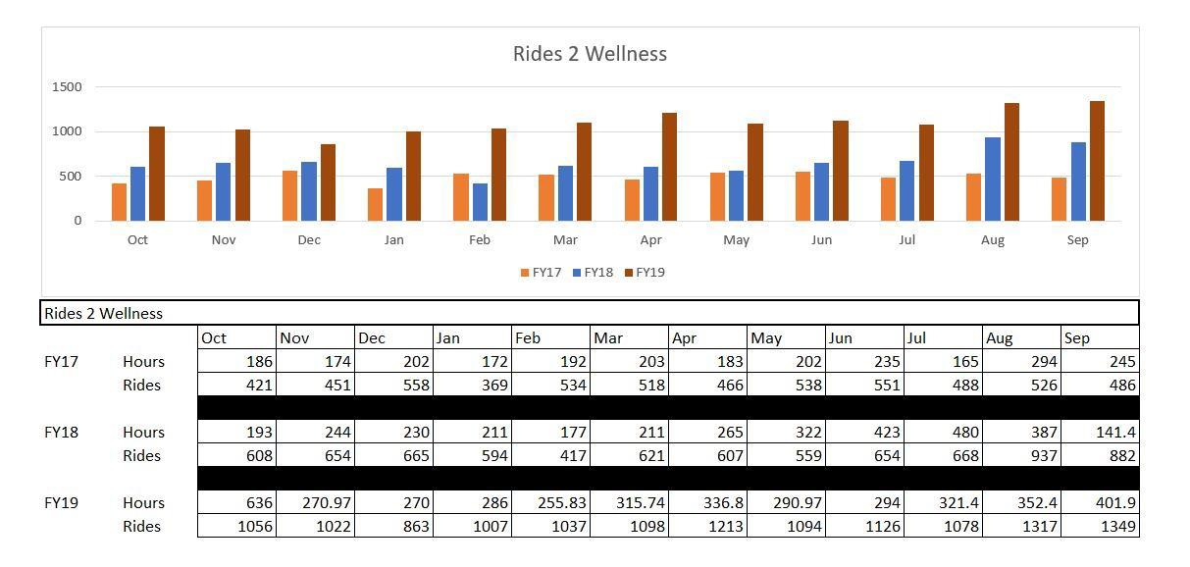
Figure 17: Shows the number of rides and service hours for Rides to Wellness in fiscal year 2017, 2018, 2019.

Transportation hours of service | Monday-Friday, 7:30 AM – 6 PM
Scheduling process | VRT Customer Service and WellRyde scheduling software
Number of vehicles in service | Varies (according to number of participating NEMT providers)
Area of service | Trips originating in Meridian, Eagle, Star, Garden City and Boise with service to specific clinics in Boise, Meridian and Eagle

Volunteer Driver Program
Valley Regional Transit Volunteer Driver Program operates in both Ada and Canyon counties. Ride requests from any person is accepted 24 hours a day, seven days a week. Filling a ride request is subject to driver availability. The Volunteer Driver program fills the gap when other transportation modes are not available.

Transportation hours of service | 24 hours a day, seven days a week
Scheduling process | VRT Help Line
Number of vehicles in service | Varies (drivers use personal vehicles)
Cost per service hour of operation | $11.81
Cost per passenger trip | $12.40
Area of service | Ada County and Canyon County

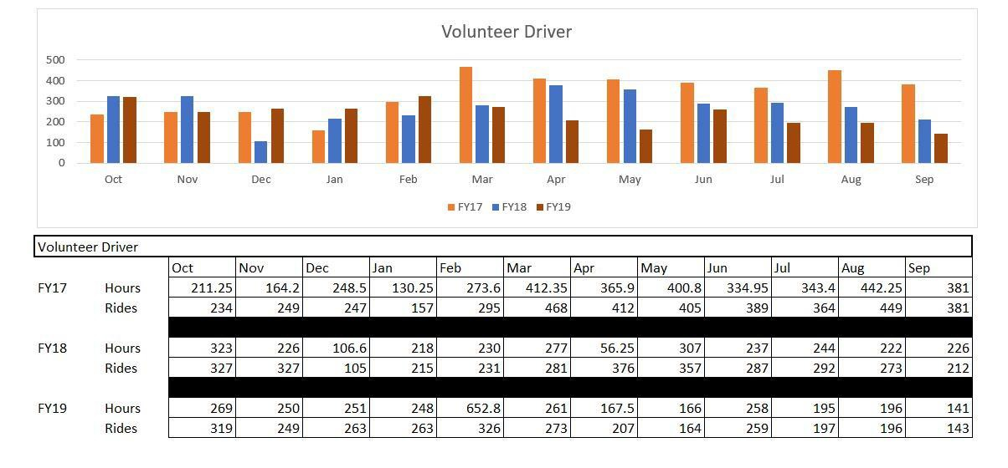
Figure 18: Shows the number of rides and service hours for the Volunteer Driver program in fiscal years 2017, 2018, 2019.
The VRT Volunteer Driver program functions as a safety net for those passengers who are seeking transportation outside the hours or service areas of other fixed line or specialized transportation services.

Acquisition of Service Transportation for Older Adults and Persons with Disabilities
The following is an analysis of program services providing transportation to seniors and persons with disabilities in Boise, Nampa, Caldwell, Kuna and the surrounding areas.

Metro Community Services – Caldwell
Metro Community Services (Metro) is a non-profit human services agency offering supportive and energy conservation services in Southwest Idaho. Metro provides assistance to seniors, people with disabilities, and financially limited individuals through a variety of human service programs. Metro offers transportation to seniors and/or disabled in Canyon County at no cost.

Transportation hours of service | Monday-Friday, 6 AM – 5 PM  (special trips outside normal business hours can be arranged using volunteer drivers)
Scheduling process | Full-time dispatcher using RouteMatch scheduling software
Total number of vehicles in service | Five (two accessible) plus three to four volunteer drivers using their own vehicles
Number of VRT Shared Vehicles in service | One
Percent of trips by ambulatory passengers | 90.7%
Percent of trips by accessible passengers | 9.3%
Cost per service hour of operation | $48.15
Cost per passenger trip | $17.92
Area of service | Caldwell, Nampa, Middleton  (with trips serving smaller communities in Canyon County by special request)

VRT provided Metro with scheduling software in fiscal year 2017 to assist in coordinating trips.
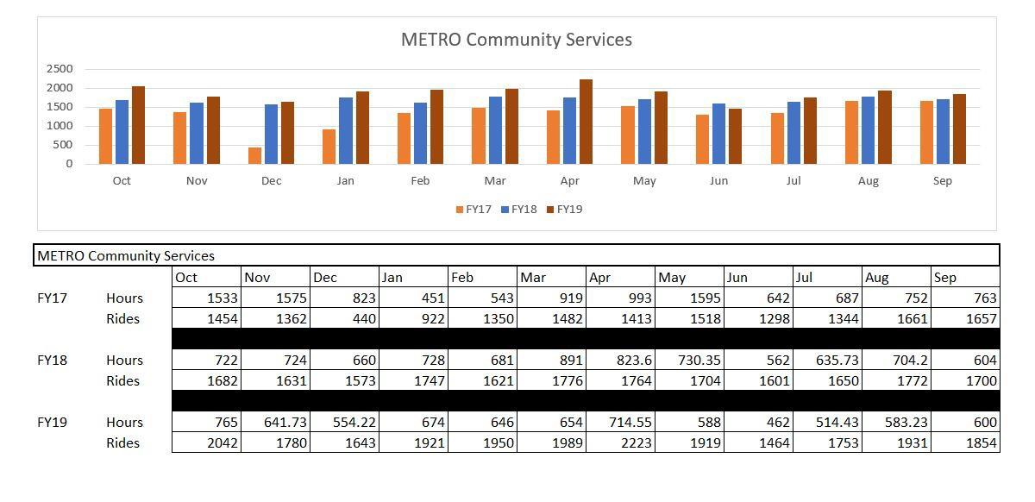
Figure 19: Shows the number of rides and service hours for the Metro Community Services program in fiscal years 2017, 2018, 2019. Rides-per-hour more than doubled with the implementation of scheduling software. Rides-per-hour increased from an average 1.43 rides-per-hour in fiscal year 2017 to 3.05 in fiscal year 2019.
Metro Community Services future potential
- Metro Community Services is well positioned to expand and extend services throughout Canyon County. With a knowledgeable support staff, experienced drivers and a solid financial base, Metro Community Services is one of VRT’s most viable transportation partners.
- Beyond AOS service – Metro Community Services is interested in expanding service beyond AOS.

Eagle Community and Senior Center Transportation
Eagle Community and Senior Center Transportation is committed to improving lives through caring support with opportunities for social interaction, recreation, and services for health and basic needs. Transportation is offered free of charge to seniors and persons with disabilities within the city boundaries of Eagle.

Transportation hours of service | Monday-Friday, 9 AM – 5 PM (special group trips are offered outside normal business hours to attend social and lifestyle activities)
Scheduling process | Full-time dispatcher using RouteMatch software
Total number of vehicles in service | Four (three accessible)
Number of VRT Shared Vehicles in service | Four
Percent of trips by ambulatory passengers | 98.2%
Percent of trips by accessible passengers | 1.8%
Cost per service hour of operation | $46.68
Cost per passenger trip | $13.64
Area of service | City of Eagle (with special group trips to venues throughout the Treasure Valley)
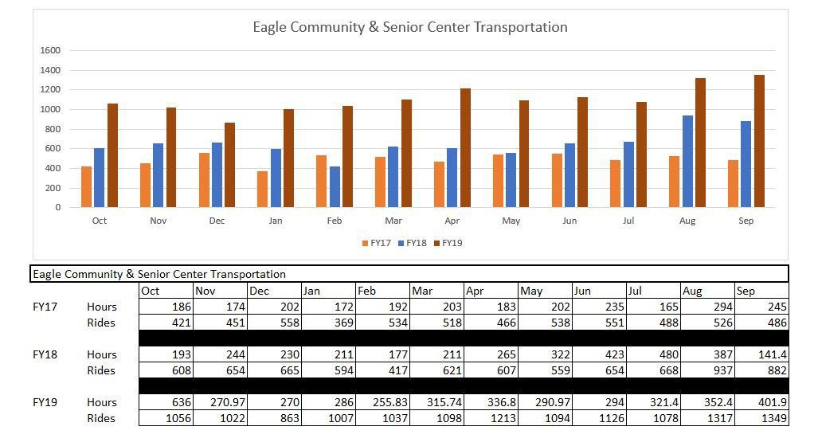
Figure 20: Shows the number of rides and service hours for the Eagle Community and Senior Center program in fiscal years 2017, 2018, 2019. With a 134 percent increase in ridership and nearly double the rides-per-hour since fiscal year 2017, Eagle Community and Senior Center Transportation is providing high-demand service to seniors and persons with disabilities.
Eagle Community and Senior Center Transportation future potential

- The Center is interested in expanding services in the future to include populations beyond AOS.

SHIP Transportation – Boise
Supportive Housing and Innovative Partnerships (SHIP) Transportation is a non-profit human services agency made up of cause-based staff and volunteers whose goal is to preserve and sustain our community. A significant part of SHIP’s mission is providing free transportation for Boise seniors, persons with disabilities and veterans. SHIP was one of the first specialized transportation providers to transition to technology-based ride scheduling.

Transportation hours of service | Monday-Friday, 7 AM – 6 PM (with limited special group trips offered for seniors and persons with disabilities outside normal business hours)
Scheduling process | Full-time dispatcher using RouteMatch software
Total number of vehicles in service | Four (three accessible)
Number of VRT Shared Vehicles in service | Four
Percent of trips by ambulatory passengers | 98.8%
Percent of trips by accessible passengers | 1.2%
Cost per service hour of operation | $44.99
Cost per passenger trip | $25.80
Area of service | Boise

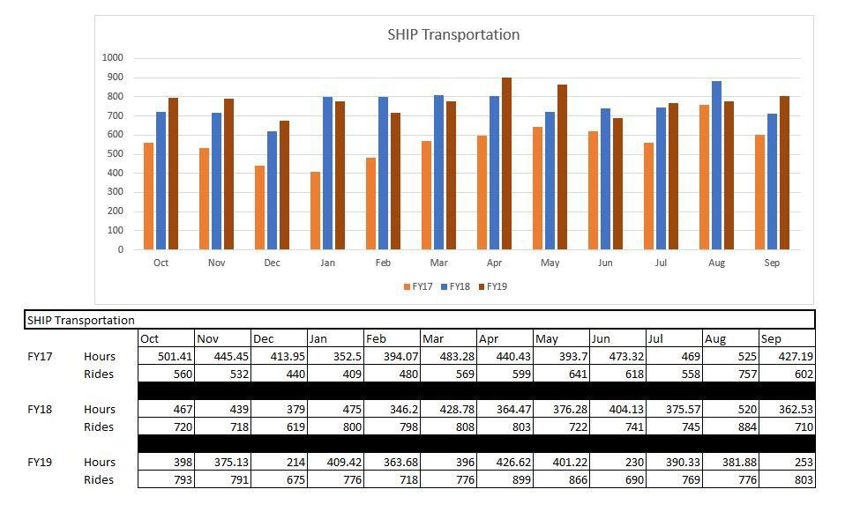
Figure 21: Shows the number of rides and service hours for the SHIP transportation program in fiscal years 2017, 2018, 2019. Rides-per-hour increased 252% with the aid of scheduling software. Rides- per-hour increased from an average 1.27 per hour in fiscal year 2017 to 2.20 in fiscal year 2019.
SHIP Transportation future potential
- SHIP Transportation has expressed an interest in adding drivers and vehicles to meet the current unmet transportation needs of Boise seniors and persons with disabilities. Rides are fully booked two to three weeks in advance.
- SHIP Transportation is interested in exploring the possibility of expanding service beyond the current AOS.

Harvest Transit – Meridian

Harvest Transit is a free transportation service in Meridian providing rides to seniors and persons with disabilities. Harvest Transit uses three accessible transit vans providing curb-to-curb service Monday through Saturday. Harvest Transit is a fully integrated transportation service provider using the latest technology in scheduling and dispatching.

Transportation hours of service | Monday-Saturday, 9 AM – 3 PM  (Special group trips and shuttle service offered outside normal business hours)
Scheduling process | Fulltime dispatcher using RouteMatch software
Number of VRT vehicles in service | 3 (three accessible)
Percent of trips by ambulatory passengers | 89.7%
Percent of trips by accessible passengers | 10.3%
Cost per service hour of operation | $56.31
Cost per passenger trip | $15.73
Area of service | City of Meridian
The city of Meridian is one of the fastest growing metropolitan areas in the United States. The 65+ senior demographic makes up a significant portion of that population growth.
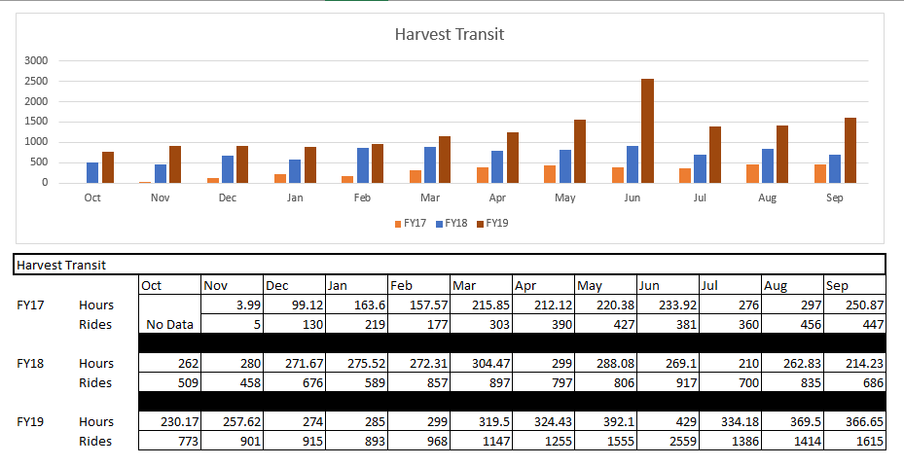
Figure 22: Shows the number of rides and service hours for the Harvest transportation program in fiscal years 2017, 2018, 2019. Harvest Transit has gone from providing 3,295 rides in 2017 to more than 15,381 rides in 2019.
Harvest Transit future potential
- Church of the Harvest has adopted community transportation through Harvest Transit as part of their church outreach. Harvest Transit is eager to expand service to include additional drivers and vehicles, expand the organizations geographic reach, and provide transportation services to additional populations and groups.

Parma Area Senior Center Transportation - Parma
Parma Area Senior Center Transportation is the only Specialized Transportation provider serving western Canyon County. The Center offers free rides for seniors and persons with disabilities in Parma, Notus, Wilder, Homedale and surrounding rural areas. Due to the remote regions served and the lack of transportation options, Parma Area Senior Center Transportation may be the only transportation service available to some for medical, pharmacy, nutrition and important lifestyle trips.

Transportation hours of service | Monday-Friday 8 AM – 2 PM  (No-charge after-hour ride appointments are based on van and driver availability)
Scheduling process | Scheduler using a manual system to log trips
Number of vehicles in service | One (accessible plus occasional volunteers using their own vehicles)
Percent of trips by ambulatory or accessible passengers | No data available
Cost per service hour of operation | $17.71
Cost per passenger trip | $8.39
Area of service | Parma and western Canyon County

In the past three years Parma Area Senior Center Transportation has worked to grow their transportation program. As a rural transportation provider, securing a sustainable source of funding has been challenging.
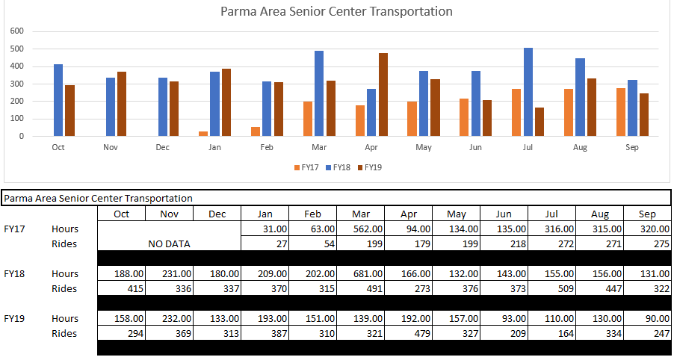
Figure 23: Shows the number of rides and service hours for the Parma Area Senior Center transportation program in fiscal years 2017, 2018, 2019.
Parma Area Senior Center Transportation future potential
- As one of very few transportation providers serving the rural areas of western Canyon County, Parma Area Senior Center Transportation is continuously seeking ways to meet the needs of seniors and persons with disabilities. The program has demonstrated in the past that if transportation is available, seniors from Parma to Homedale and Wilder to Notus will use the service. Future transportation expansion is dependent on a secure, sustainable source of funding.

Meridian Senior Center Transportation – Meridian

Meridian Senior Center provides members and others in the Meridian and Western Boise area with free transportation. Ride reservations for seniors and persons with disabilities are accepted for meals, medical appointments, nutrition and shopping. Special outside groups trips are occasionally offered.

Transportation hours of service | Monday-Friday, transportation schedule varies by day and event
Scheduling process | Scheduler using a manual system to log trips
Number of vehicles in service | One (accessible) vehicle per provider
Percent of trips by ambulatory or accessible passengers | No data available
Cost per service hour of operation | $57.53
Cost per passenger trip | $15.65
Area of service | Meridian and Western Boise
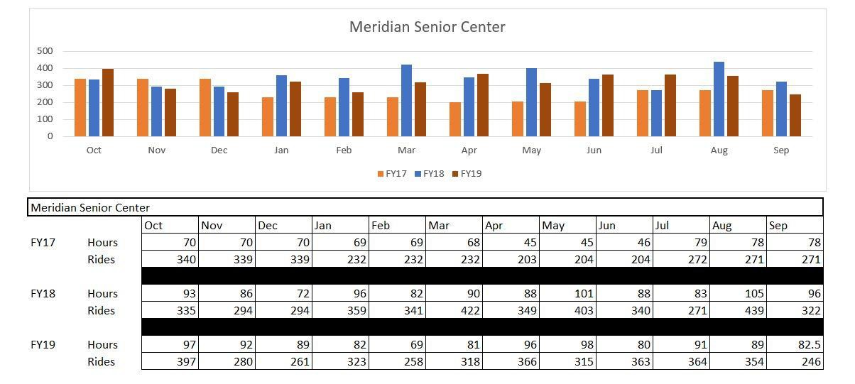
Figure 24: Shows the number of rides and service hours for the Meridian Senior Center transportation program in fiscal years 2017, 2018, 2019.
Meridian Senior Center Transportation future potential
- Meridian Senior Center Transportation provides exemplary service to primarily the senior center’s members. Meridian Senior Center has shown interest in expanding service to additional populations with expanded service hours.

Star Senior Center Transportation - Star
Star Senior Center provides members and others in the Star and Eagle area with free transportation. Star is focused on providing their core customer base with exceptional service. Special outside group activities and trips are offered on a regular basis.

Transportation hours of service | Tuesday-Friday, transportation schedule varies
Scheduling process | Scheduler using a manual system to log trips
Number of vehicles in service | One (accessible) vehicle
Percent of trips by ambulatory or accessible passengers | No data available
Cost per service hour of operation
Cost per passenger trip | $12.33
Area of service | Star and Eagle
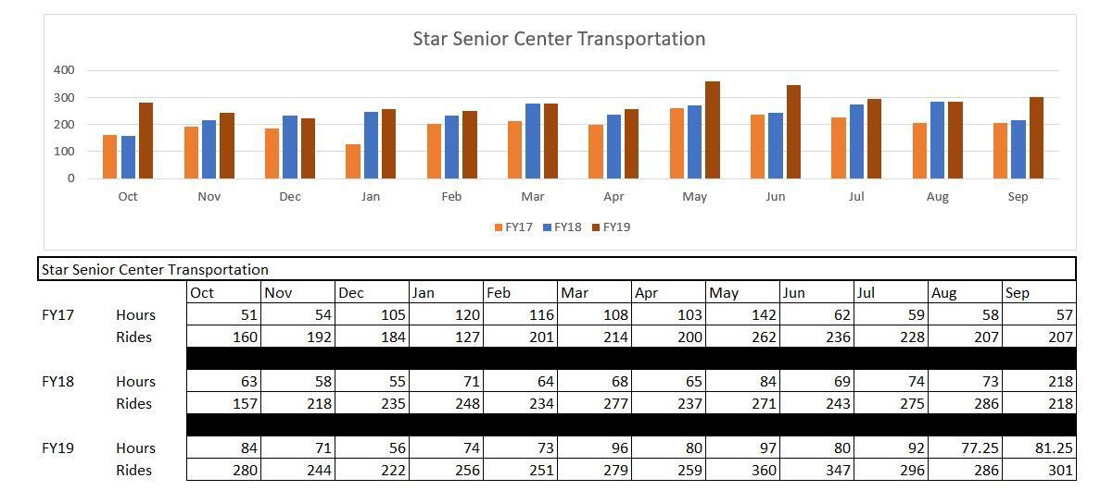
Figure 25: Shows the number of rides and service hours for the Star Senior Center transportation program in fiscal years 2017, 2018, 2019.
Star Senior Center Transportation future potential

Star Senior Center serves the seniors and persons with disabilities with safe, professional transportation. Many of the Star customers are also Eagle customers. Star is interested in expanding hours of service to better serve their customers.

Kuna Senior Center - Kuna

Kuna Senior Center provide members and others with free transportation. Rides to the Center are scheduled on a regular basis. Kuna Senior Center also schedules regular trips to Meridian and Boise for groceries, doctor appointments and shopping.

Transportation hours of service | Monday-Friday, transportation schedule varies by day
Scheduling process | Scheduler using a manual system to log trips
Number of vehicles in service | One (accessible) vehicle per provider
Percent of trips by ambulatory or accessible passengers | No data available
Cost per service hour of operation | N/A
Cost per passenger trip | $5.52
Area of service | Kuna and surrounding areas
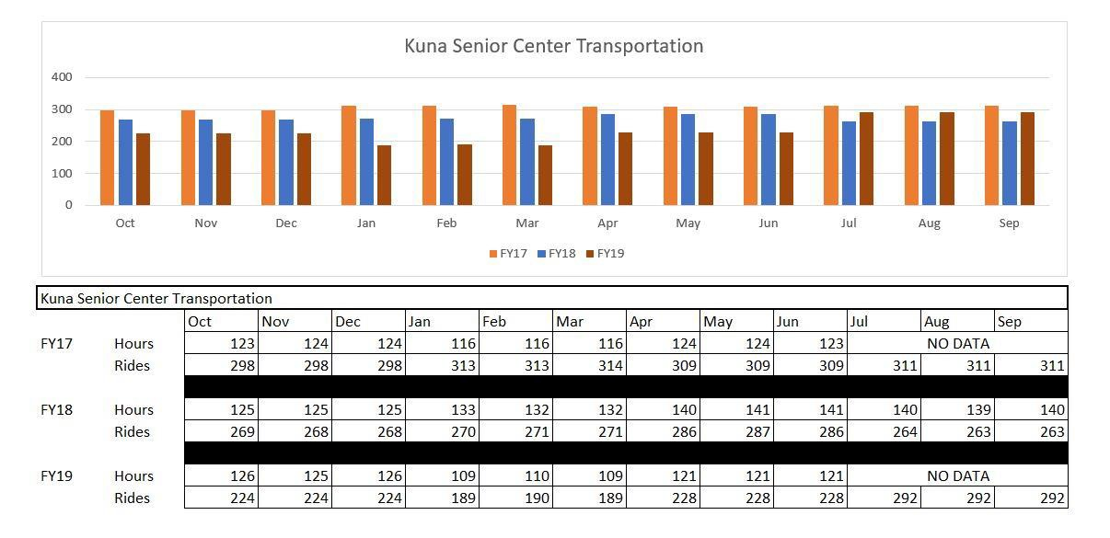
Figure 26: Shows the number of rides and service hours for the Kuna Senior Center transportation program in fiscal years 2017, 2018, 2019.
Kuna Senior Center Transportation future potential
- Kuna Senior Center is focused on providing exceptional service to their core customer base, and have expressed an interest in increasing current operations with additional hours of service.

Treasure Valley Transit – Nampa
TVT receives 5310 and 5311 formula grants. 5310 formula grants provide funding for seniors and persons with disabilities in urban and rural areas. 5311 formula grants provide funding for senior and persons with disabilities in rural areas with fewer than 50,000 residents. VRT also provides 5307 Small Urban funding to TVT for seniors and persons with disabilities who are beyond the ADA core ValleyRide fixed route service in the Nampa-Caldwell service area.
TVT fiscal year 2019 Statistics

TVT Passenger Trips | 26,603
Cost Per Trip | $7.78
Revenue Service Hours | 13,608
Revenue Miles | 139,327
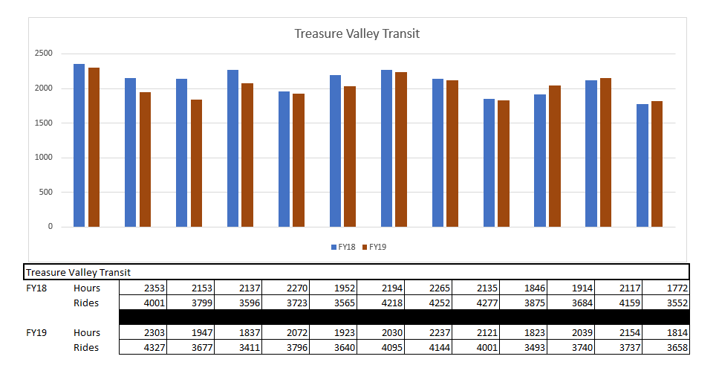
Figure 27: Shows the number of rides and service hours for the Treasure Valley Transit program in fiscal years 2017, 2018, 2019.

Treasure Valley Transit partners with VRT in serving seniors and persons with disabilities. TVT has expressed an interest in being a part of expanded service as described in Valley Connect 2.0. Potential Canyon County passengers who do not meet eligibility for ADA Paratransit Service and are unable to access ValleyRide fixed route service would benefit from this expanded service.

Appendix B | Survey 1: Community Advocate Survey
This section includes questions from the Community Advocate survey. The survey was distributed in September and October 2021. For readability, not all explanatory materials are included.
- Please write your name below.
- Please write your email address below.
- Which group/committee do you belong to? Mark all that apply.
  - Regional Advisory Committee
  - Ada County Highway district ADA Advisory Committee
  - Public Transportation Provider Group
  - Other
- Who do you represent in the group/committee?
- Would you be willing to help us reach out to the population you represent?
  - Yes
  - No
- If you answered yes, please mark the best way to contact you.
  - Phone
  - Email
  - Video
  - Other
- If you would like to be contacted by phone, please write the number at which to contact you below.
- Please list organizations in the Treasure Valley that serve the population you represent.
- What difficulties does the population you represent face when riding public transit?
- What changes or trends do you see occurring that might affect transportation services (demographics, employment, housing, land development, technology)?
- What infrastructure improvements would you suggest to improve access to transit services (e.g., information, technology, programmatic supports, ADA, and/or other hard infrastructure improvements)?
- What service improvements or expansions would you suggest to improve access to transit services?
- How would you suggest to better coordinated transit service between different organizations?
- What ideas do you have for future transportation studies or technical analyses?
- Please write any additional comments you may have below (anecdotal evidence, etc.)

Appendix C | Survey 2: Stakeholder Survey
This section includes questions from the Stakeholder survey. The survey was distributed in September and October 2021. For readability, not all explanatory materials are included.
- Which of the following populations do you identify with?
  - Older Adults
  - Individuals with a disability
  - Individuals with Low-Income
  - English Language Learners
  - Other
- If you do not currently drive a personal vehicle, please explain why by marking the choice(s) that apply to you.
  - Cannot afford price of maintenance
  - Cannot afford price of fuel
  - Feel uncomfortable driving
  - Are not physically able to drive
  - Do not own a vehicle
  - Legally cannot drive
  - Not applicable. I am able to drive
- Please select the transit services you currently use of have used in the past. If a service is not listed, please specify.
  - Shuttle to medical services
  - The bus (ValleyRide)
  - Vanpool services
  - Discounted Lyft rides
  - None (walk, rides from friends/family, own a car)
  - Other
- How often can you get to where you need to go using existing transit services?
  - All the time
  - Most of the time
  - Some of the time
  - Very infrequently
  - Never (I do not use public transit)
- Where do you need to go? (Please include time of day)
- Where do you want to go? (Please include time of day)
- What difficulties do you have using public transit services?
- What infrastructure improvements would help you use transit services? (multi-lingual signage, benches at bus stops, ADA improvements, technological improvements, etc.)
- What service improvements or expansions would help you use public transit services? (Service at certain times, online bus tracking system, multi-lingual services, etc.)
- What is your home zip code?
- What is your gender?
  - Female
  - Male
  - Other
  - Prefer not to answer
- What is your age?
  - Under 21
  - 22-34
  - 35-44
  - 45-54
  - 55-64
  - 65+
  - Prefer not to answer
- What is your annual household income?
  - Less than $25,000
  - $25,000-$35,000
  - $36,000-$45,000
  - $46,000-$65,000
  - $66,000-$85,000
  - $86,000-or more
  - Prefer not to answer
- How do you self-identify by race?
  - White
  - Black or African American
  - Asian or Asian American
  - American Indian or Alaska Native
  - Native Hawaiian or other Pacific Islander
  - Another race
  - Prefer not to answer
- Are you Hispanic or Latino/a/x?
  - Yes
  - No
  - Prefer not to answer
- For English Language Learners Only: How would you rate your English language proficiency?
  - Proficient
  - Intermediate
  - Basic
  - Below basic
  - Prefer not to answer
- Do you use a ramp or lift to enter/exit a vehicle?
  - Yes
  - No
  - Prefer not to answer
- Do you require personal assistance to travel? (Personal aide, nurse family member, etc.)
  - Yes
  - No
  - Prefer not to answer
- If you are taking this survey on behalf of someone, please describe your relationship.

Appendix D | Outreach Process and Public Comment Received
The draft Coordinated Plan was open for public comment from April 15 through May 15, 2022. During that time, 14 individuals submitted comments. While comments were accepted on any part of the draft plan, commenters were specifically asked for feedback on the identified needs and strategies to meet those needs.
The outreach process is described below, followed by demographic characteristics of commenters, quantitative results, and open-ended comments.
All comments were considered, and questions raised were answered. Comments were generally positive and varied widely, ranging from questions regarding the development of the plan, to very specific comments on individual bus routes, to broad comments in support of, or opposition to, public transportation. Comments and responses were shared with Valley Regional Transit, other public agencies when appropriate, and the COMPASS Board of Directors. Maps in the plan were reformatted to be full page size for easier reading based on a comment received. No other changes were made to the draft plan based on public comments.
Outreach Process
The outreach plan developed for the Coordinated Plan followed the guidance and requirements in COMPASS’ 2021 Participation Plan (click here to link) and was reviewed by the COMPASS Public Participation Workgroup.
COMPASS conducted broad community outreach using a variety of outreach methods, in addition to targeted outreach to the populations specifically addressed in this plan: elderly and individuals with low incomes, disabilities, and limited English proficiency. Outreach methods included email, social media, newspaper advertisements, guest opinions in the region’s two largest newspapers, and flyers and outreach materials available around the valley, including distribution at a food bank, senior centers, and libraries (as described in Figure D-1, below).
Figure D-1: Coordinated Plan outreach mix.
- Email outreach:
  - Three email blasts sent to 6,000+ recipients each.
  - Twenty-three personal, targeted emails sent to individuals and stakeholder groups.
- Social Media outreach:
  - Fifteen social media posts on COMPASS channels
  - Eighty-six paid social media posts across multiple Spanish language channels.
  - Numerous additional social media posts, reposts, and shares by partner agencies.
- Advertising outreach:
  - Eleven print newspaper ads across four newspapers
  - Six legal notices across two newspapers.
- Events:
  - One virtual open house on Facebook live with 44 views.
  - Two in-person open houses:
    - One at Main Street Station, Boise
    - One at the Nampa Public Library, Nampa.

- Public Access (resources COMPASS provided):
  - COMPASS website
  - One news release
  - Valley Regional transit bus splash page
  - Materials available for review in 24 public locations, including libraries, senior centers, and more.
- Word of mouth outreach:
  - Guest opinion published in two newspapers
  - Flyers were posted at 26+ locations
  - Announcements made at community meetings and events
  - 800 flyers distributed in food boxes through the Meridian Food Bank.
In addition to the outreach methods described above, all public comment materials were available on the COMPASS website in English and Spanish in PDF and Word (screen-reader compatible) versions. An online comment form (English and Spanish; screen-reader compatible) was available for comments, as were paper copy comment forms in English and Spanish, and the ability to submit comments via email, letter, or fax.
In addition to formal comments received, COMPASS received informal comments from individuals who stopped by COMPASS’ open houses, but did not sign in, review materials, or discuss the plan itself. Those informal comments included:
- A desire for more evening and weekend bus service, specifically serving Boise State University and the Walmart on Overland Road in Boise.
- A desire for increased bus services overall.
- A frustration with, and dislike of, the on-demand bus service in Canyon County, with a perception that the rider must “negotiate” for a ride then walk a long distance to catch that ride. There was strong preference by the individual for traditional, fixed-route service.
When respondents were asked how they learned about the opportunity to comment, email and social media were the two most common methods cited (explained in Figure D-2, below). While no one indicated they learned about the opportunity to comment via COMPASS’ website, all comments were submitted via the online comment form accessed through COMPASS’ website, indicating that all responded did visit the COMPASS website at some point.
In its outreach materials, COMPASS offered to mail paper copies of the draft plan and comment materials upon request. Two individuals requested paper copies be mailed to them.
Figure D-2: Outreach mix results. (Respondents could select more than one answer, so total responses are greater than the total number of respondents).
- When asked “How did you learn about the opportunity to comment?” respondents stated:
  - 6 respondents learned through email
  - 4 respondents learned through social media
  - 2 respondents learned through News stories
  - 1 respondent learned from a newspaper ad
  - 2 respondents learned from a flyer
  - There were 0 respondents who learned from word of mouth, the COMPASS website, or other.
Demographic Characteristics
Fourteen individuals submitted comments via the online comment form; no comments were received in any other format. All comments were submitted in English. The form included questions on demographics (explained in Figure D-3 below) and how respondents learned of the opportunity to participate (Figure D-2, titled “outreach mix results” above). Commenters were predominantly older (65+) and white, with slightly more females responding than males. Approximately one-third reported having a disability.
Figure D-3: Demographic characteristics of respondents.
- When asked their age:
  - 3 respondents were in the age group between 20 and 34.
  - 1 respondent was in the age group between 35 and 49.
  - 2 respondents were in the age group between 50 and 64.
  - 6 respondents were in the age group 65 and older.
- When asked what their race or ethnicity was:
  - 0 respondents were Native American/Alaska Native
  - 1 respondent identified as Asian/Pacific Islander
  - 1 respondent identified as Black
  - 1 respondent identified as Hispanic/Latino
  - 11 respondents identified as white
  - 0 respondents identified as mixed.
  - 0 respondents identified as other.
- When asked their gender:
  - 5 respondents were male.
  - 7 respondents were female.
  - 1 respondent was other.
- When asked if they have a disability:
  - 5 respondents replied yes.
  - 8 respondents replied no.

Respondents were also asked their zip code to help determine the geographic distribution of commenters. Respondents hailed from both Ada and Canyon Counties, with 10 respondents from Ada County and 4 from Canyon County (As explained below in Figure D-4). While Ada County has a larger population than Canyon County, Canyon County is nevertheless under-represented in respondents.
Figure D-4: 2022 Coordinated Public Transit-Human Services Transportation Plan geographical distribution of respondents.
The number of public comment responses by zip code are as follows:
- 1 comment from 83642 (Ada County)
- 1 comment from 83713 (Ada County)
- 2 comments from 83605 (Canyon County)
- 2 comments from 83616 (Ada County)
- 1 comment from 83646 (Ada County)
- 2 comments from 83651 (Canyon County)
- 1 comment from 83702 (Ada County)
- 1 comment from 83703 (Ada County)
- 2 comments from 83705 (Ada County)
- 1 comment from 83716 (Ada County)

Public Comments Received

While comments were welcome on any part of the Coordinated Plan, the comment form focused on identified priority needs and strategies to meet those needs. For each of these two issues, respondents were asked to rate their agreement with the needs and strategies on a scale of 1 to 5, with 1 indicating strong disagreement and 5 indicating strong agreement. For both questions, no respondent answered, “strongly disagree,” and for both questions, the average rating was greater than 4.0, indicating general agreement.

Specific questions asked, quantitative results, and open-ended responses are provided below in (Figures D-5 and D-6; Tables D-1 through D-3).

Do you agree with the identified priority needs?

Figure D-5: Agreement with priority needs from respondents:
- 50% of respondents strongly agreed.
- 29% of respondents agreed.
- 14% of respondents disagreed.
- 7% of respondents neither agreed nor disagreed
  - The average score was 4.14

Do you agree with the strategies to help meet the high-priority needs?
Figure D-6: Agreement with strategies to meet priority needs.
- 46% of respondents strongly agreed.
- 31% of respondents agreed.
- 15% of respondents disagreed.
- 8% of respondents neither agreed nor disagreed.
  - The average score was 4.08

Table D-1: Open-ended responses regarding needs.
Question asked: What comments do you have on the priority needs? Are there higher priority needs that should be included?
Comment  (The comments below are verbatim, as submitted by the commenter. As such, typographical errors have not been corrected.) | Staff Response | Zip Code (City)  Name Affiliation | Format
Comment: Why not just subsidize transportation using Lyft or Uber? Much cheaper than building a new transportation infrastructure. | Staff response: Thank you for your comments. They will be shared with Valley Regional Transit and the COMPASS Board of Directors.  Subsidizing Lyft service is currently part of the transportation mix offered by Valley Regional Transit:  - Valley Regional Transit Late Night: Qualified low-income residents can get $3 Lyft rides from 9pm to 6am (hours outside of public bus service).  - Lyft Transit Connections: Riders may travel to a Valley Regional Transit bus stop via Lyft for $2. Costs that exceed $8 are the rider’s responsibility. This service is only available in a portion of Garden City and Boise.  More details regarding both of services can be found on Valley Regional Transit’s website at www.valleyregionaltransit.org/. | Zip Code: 83646 | Format: Online comment form
Comment: Report was well done and well organized. Not clear to me how Pri #1-Pri#7 were established as important but they seem to cover the bases. Also, some maps are only half page and hard to see, so it would be helpful to make them full-page where possible. | Staff response: Thank you for your comments. They will be shared with Valley Regional Transit and the COMPASS Board of Directors.  Results from a survey conducted last fall and demographic information from 2010-2019 were used to create a list of unmet transportation needs. The seven “highest priority” needs were identified from that list by Valley Regional Transit’s Regional Advisory Council (RAC), a group consisting of public transportation advocates and users. More information on the RAC can be found on Valley Regional Transit’s website at www.valleyregionaltransit.org/about-us/oversight/  Maps were re-formatted to be full page size for easier reading. | Zip code: 83713  Name: Marc Maupin | Format: Online comment form
Comment: Public Transportation is a huge, never ending money pit. | Staff response: Thank you for your comments. They will be shared with Valley Regional Transit and the COMPASS Board of Directors. | Zip code: 83705 | Format: Online comment form
Comment: Not sure why not being proficient in English qualifies at all. And just being old does not seem to be a qualification? | Staff response: Thank you for your comments. They will be shared with Valley Regional Transit and the COMPASS Board of Directors.  Federal guidance requires that needs of persons with disabilities, older adults, persons with low incomes be addressed in the Coordinated Plan, which is required for project proposals to be eligible to receive funding from the Federal Transit Administration’s Section 5310 program - Enhanced Mobility of Seniors and Individuals with Disabilities. Community advocates and service providers in Ada and Canyon Counties chose to also include individual with limited English skills as a target population due to unique vulnerabilities of those individuals. | Zip code: 83616 | Format: Online comment form
Comment: Love it and I’m super excited! But, as someone who wants to use more alternative transportation, I don’t know where to start. I think an app that can connect any two places in the Treasure Valley without my personal car should be a priority. The Valley Connect app is a start, but it would be cool if it could mix biking and busing (not just walking). | Staff response: Thank you for your comments. They will be shared with Valley Regional Transit and the COMPASS Board of Directors.  In addition to Valley Regional Transit’s app, the “Share the Ride” website sharetherideidaho.com/#/pages/commuteride assists with commute options, including walking and biking. | Zip code: 83616 | Format: Online comment form
Comment: There should be a strong push toward Electric Vehicles. | Staff response: Thank you for your comments. They will be shared with Valley Regional Transit and the COMPASS Board of Directors. | Zip code: 83605 | Format: Online comment form
Comment: More transportation options at affordable pricing and expanded to City of Meridian. | Staff response: Thank you for your comments. They will be shared with Valley Regional Transit, the City of Meridian, and the COMPASS Board of Directors. | Zip code: 83642 | Format: Online comment form
Comment: If I'm being idealistic, I'd say using the trains for public transportation would be a great investment for commuters between cities (caldwell, nampa meridian,) a more realistic priority goal is just increasing public transportation (buses/trams) | Staff response: Thank you for your comments. They will be shared with Valley Regional Transit and the COMPASS Board of Directors. | Zip code: 83605 | Format: Online comment form
Comment: Access to shops, grocery stores, day cares, schools. pharmacy's and other essential services. but also libraries. | Staff response: Thank you for your comments. They will be shared with Valley Regional Transit and the COMPASS Board of Directors. | Zip code: 83702 | Format: Online comment form
Comment: I live by Albertsons 715 12th Ave South Nampa almost 2 blocks behind Albersons and I have to walk to Albertsons or to the First Christian Church to catch the bus when it goes right by my house on [address removed for privacy] one the 8th Street side and it is not an option for me to catch it right at my carport. Others get transit right in front of their door, but I don't. #2 I have to ride around on the [comment ended] | Staff response: Thank you for your comments. They will be shared with Valley Regional Transit and the COMPASS Board of Directors. | Zip code: 83651  Name: Karen Stiehl | Format: Online comment form

Table D-2: Open-ended responses regarding strategies.
What comments do you have on the strategies? Are there different or additional strategies to better meet the priority needs?
Comment  (The comments below are verbatim, as submitted by the commenter. As such, typographical errors have not been corrected.) | Staff Response | Zip Code (City)  Name Affiliation | Format
Comment: Why not just subsidize transportation using Lyft or Uber? Much cheaper than building a new transportation infrastructure. | Staff Response: Thank you for your comments. They will be shared with Valley Regional Transit and the COMPASS Board of Directors.  Subsidizing Lyft service is currently part of the transportation mix offered by Valley Regional Transit:  - Valley Regional Transit Late Night: Qualified low-income residents can get $3 Lyft rides from 9pm to 6am (hours outside of public bus service).  - Lyft Transit Connections: Riders may travel to a Valley Regional Transit bus stop via Lyft for $2. Costs that exceed $8 are the rider’s responsibility. This service is only available in a portion of Garden City and Boise.  More details regarding both of services can be found on Valley Regional Transit’s website at https://www.valleyregionaltransit.org/. | Zip code: 83646 | Format: Online comment form
Comment: Good cross section of folks surveyed. | Staff Response: Thank you for your comments. They will be shared with Valley Regional Transit and the COMPASS Board of Directors. | Zip code: 83713  Name: Marc Maupin | Format: Online comment form
Comment: The money the taxpayer will spend on Public Transportation could by a car. | Staff Response: Thank you for your comments. They will be shared with Valley Regional Transit and the COMPASS Board of Directors. | Zip Code: 83705 | Format: Online comment form
Comment: Running more buses more days longer hours and more routes is not wise. Many buses run empty or with very few passengers now. Point to point transportation seems a much wiser use of our tax dollars and could probably provide better service for those in need. | Staff Response: Thank you for your comments. They will be shared with Valley Regional Transit and the COMPASS Board of Directors. | Zip code: 83616 | Format: Online comment form
Comment: Need to persuade investors to fund large high rise housing for diverse populations, including workforce, section 8, 55+, refugees, etc. These housing high rises could have their own fixed transit buses that go just between the complex and worker-intense areas like downtown, Micron, plus grocer store and hospital areas. | Staff response: Thank you for your comments. They will be shared with Valley Regional Transit and the COMPASS Board of Directors. | Zip code: 83716 | Format: Online comment form
Comment: Unless there is a move to electric vehicles, the inversions in the valley will only get worse. | Staff response: Thank you for your comments. They will be shared with Valley Regional Transit and the COMPASS Board of Directors. | Zip code: 83605 | Format: Online comment form
Comment: #2: Increase availability of accessible vehicles for demand response services, including specialized transportation. #3: Expand marketing & outreach efforts to ensure residents are aware of transportation options within the region (Meridian, Boise, Tampa). #4: Expand programs that train people on how to use available transportation options. | Thank you for your comments. They will be shared with Valley Regional Transit and the COMPASS Board of Directors. | Zip code: 83642 | Format: Online comment form
Comment: make the city less car dependent, its healthier for the public and the environment and its great for local businesses since it increases foot traffic especially in downtown caldwell. Also allow mix zoning and reduce single family zoning (too many subdivisions makes the city wider which makes it more car dependent) adding another lane in the highway doesnt decrease congestion, public transport does. At the very least have better/more sidewalks and bike paths (too many cars cross the painted bike bath endangering cyclists. There needs to be a safer barrier) | Staff response: Thank you for your comments. They will be shared with Valley Regional Transit, the City of Caldwell, and the COMPASS Board of Directors. | Zip code: 83605 | Format: Online comment form
Comment: We need increased service hours on weekdays nto the evening and during the day so that low income people can rely on public transport for work and getting to daycare to drop off kids. , Need more reliable buses that actually show up. The last bus can easily be missed. Airport connections are important too. Long distance bus stations too. Public transport is not just for getting around town. Inter City transit that you can ork in Boise and live in Nampa. | Staff response: Thank you for your comments. They will be shared with Valley Regional Transit and the COMPASS Board of Directors. | Zip code: 83702 | Format: Online comment form
Comment: Increase availability when booking the bus because of extreme high demand and shorter wait times. Make a connection like the old 55 bus booked for the 42 leaving Tiegs and. Franklin at 9:50. AM. Timing on 150 is a problem. The 42 leaving at 10:50 maybe also? | Staff response: Thank you for your comments. They will be shared with Valley Regional Transit and the COMPASS Board of Directors.  Valley Regional Transit is in the process of looking at service changes for fall 2022. Your question and suggestions regarding timing have been forwarded to Valley Regional Transit planning staff for consideration as part of that process. | Zip code: 83651  Name: Karen Stiehl | Format: Online comment form

Table D-3. Additional open-ended response.
Do you have any additional comments on the draft plan?
Comment  (The comments below are verbatim, as submitted by the commenter. As such, typographical errors have not been corrected.) | Staff Response | Zip Code (City)  Name Affiliation | Format
Comment: As a 70+ disabled veteran in Boise, using the VA, could you explain the curb-to-curb services from my home to the VA? Is there a fee? I see the days and times it is offered but NO phone number so that would solve my issue. | Staff response: Thank you for your comments. They will be shared with Valley Regional Transit and the COMPASS Board of Directors.  The Boise VA Medical Center operates a shuttle service that transports patients to the VA. To schedule a ride, you can call the Boise VA local number at (208) 422-1000 and press “0” for the operator. Rides must be scheduled at least two business days before your appointment and are offered free of charge.  If that service does not meet your needs or you have more questions about available curb-to-curb services, the Valley Regional Transit Help Desk at (208) 345 -7433 is also a good resource. | Zip code: 83713  Name: Marc Maupin | Format: Online comment form
Comment: Vote to oust Liberal Democrates in Boise. | Staff response: Thank you for your comments. They will be shared with Valley Regional Transit and the COMPASS Board of Directors. | Zip code: 83705 | Format: Online comment form
Comment: I appreciate the work that has been done on this plan. I ride the bus on a regular basis and overhear conversations of people who are truly struggling to commute to work, to doctor's appointments, to church, to the grocery store. They are having to move further away from jobs that pay a sustainable income because they can not afford to pay rent where the jobs that pay well are located. We need to be moving faster in improving public transit for people in the Treasure Valley - especially in Canyon County and west Ada County. | Staff response: Thank you for your comments. They will be shared with Valley Regional Transit and the COMPASS Board of Directors. | Zip code: 83703 | Format: Online comment form
Comment: Why is your priority demographic only the elderly, disabled and refugees? We need a public transit system for everyone. We don't want a car-dependent city. Public transit in Boise should be so appealing and well thought out that it makes sense for the average citizen to ditch their car and ride together. The growth of the Valley is inevitable, lets build a community that is not dependent on cars! | Staff response: Thank you for your comments. They will be shared with Valley Regional Transit and the COMPASS Board of Directors.  Federal guidance requires that needs of persons with disabilities, older adults, persons with low incomes be addressed in the Coordinated Plan, which is required for project proposals to be eligible to receive funding from the Federal Transit Administration’s Section 5310 program - Enhanced Mobility of Seniors and Individuals with Disabilities. Community advocates and service providers in Ada and Canyon Counties chose to also include individual with limited English skills as a target population due to unique vulnerabilities of those individuals.  While the focus is on the needs of these individuals, any improvements to transit will benefit all transit users. | Zip code: 83705 | Format: Online comment form
Comment: Although this is a great and comprehensive plan that addresses current and short-term needs, I don't think we will truly address longer term needs and anticipated growth without a mass transit system like light rail. | Staff response: Thank you for your comments. They will be shared with Valley Regional Transit and the COMPASS Board of Directors. | Zip code: 83651 | Format: Online comment form
Comment: Consider expanding Commuter Ride by ACHD to deal with some of these "high priority" needs. Locating "low income" housing near bus routes seems wise. | Staff response: Thank you for your comments. They will be shared with Valley Regional Transit, Ada County Highway District (ACHD) Commuteride, and the COMPASS Board of Directors. | Zip code: 83616 | Format: Online comment form
Comment: We should focus on make the entire TV less auto dependent by funding a long term project to build a light rail system from Middleton to Mtn Home. This would bring an encredible # of jobs in which would in turn help the lower income folks penalized by our sub-parr public transit system. Also, persuaidng the state welfare system to provide lower models cars (like the ones donated to Youth Ranch) to those on public assistance would actually reduce the need for expensive fixed transit programs. People hate riding the bus and we force poor people do do it; whichonly hinders their ability to get off public assistance. | Staff response: Thank you for your comments. They will be shared with Valley Regional Transit and the COMPASS Board of Directors. | Zip code: 83716 | Format: Online comment form
Comment: Increase service hours during week and on weekends Increase availability of qualified (transit) drivers in the region (Meridian, Boise, Nampa) Expand existing inter county public and other transportation services | Staff response: Thank you for your comments. They will be shared with Valley Regional Transit and the COMPASS Board of Directors. | Zip code:  83642 | Format: Online comment form
Comment: I lived and visited countries that actually had good public transportation and loved it but hate how limited it is here in Caldwell. If you want to incentivize the public to use public transportation, I'd say give senior/student discounts. A great marketing tactic that could peak the curiosity of the public is having the bus aesthetic as a unique selling point (ie. A double decker bus in idaho would be a first or an interesting retro style, something that catches the eye) it would also be great for tourism | Staff response: Thank you for your comments. They will be shared with Valley Regional Transit, the City of Caldwell, and the COMPASS Board of Directors. | Zip code: 83605 | Format: Online comment form
Comment: need to consider other modes of transit not just buses. BRT or Street Cars. Community rides. in a community where many older people can't drive but need to get around they should not have to rely on Ubers taxi's and family members for rides or access buses that only operate a few days a week. I think you say this in the strategies but Sunday services should not be different from Saturday or weekday. Lack of service results in a lack of independence. | Staff response: Thank you for your comments. They will be shared with Valley Regional Transit and the COMPASS Board of Directors. | Zip code: 83702 | Format: Online comment form
Comment: Need benches at Tiegs and Franklin, the Marketplace, or maybe just signage at 12th & 7th both sides. #12 every half hour. Saturdays for 150 routes decrease booking and wait times for 150. Is the 30 kicking in yet? When?. Need for Meridian ASAP | Staff response: Thank you for your comments. They will be shared with Valley Regional Transit and the COMPASS Board of Directors.  At this time, an exact start date for route 30 has not been set. Valley Regional Transit was planning to set a start date when ridership on its system reached 90% of pre-COVID 19 levels. That may be modified to begin service no later than October 1. | Zip code: 83651  Name: Karen Stiehl | Format: Online comment form

https://www.compassidaho.org/people/publicinvolvement.htm#pp

